

Ireland Neighbourhood Watch Application for Android Devices

Interim Report

DT228

BSc in Computer Science

Patrick Cummins

C10707541

Edina Hatunic-Webster

# Abstract

This project was designed and written with the intention of providing the public with an application for their mobile devices that will kept them informed of suspicious or dangerous activities that may happen within their area. Along with letting the public report any suspicious or dangerous activities that they may witness.

Hopefully this thesis will guide the readers only the path that I took when developing this application. Starting from the very start when I had just an idea in my head to when I have an application in the app stores.

The objective of the whole project is to bring a sense of security to the public. They can feel more safe and comfortable within their homes or neighbourhood knowing that they have up-to date information about their neighbourhood at their fingertips.

Table of Contents

Table of Contents

Abstract 2

Chapter 1 – Project Proposal 8

1.1 Introduction 8

1.2 Project Background 10

1.3 Project Aims and Objectives 12

1.3.1 The most important criteria: 12

1.3.2 Deliverables: 12

1.3.3 Priority Features: 12

1.3.4 Secondary Features: 13

1.4 Conclusion 13

Chapter 2. Research 13

2.1 Introduction 13

2.2 Similar Mobile Applications 13

2.2.1 Neighbourhood Crime Watch 14

2.2.2 Crime Watch 14

2.2.3 Neighbourhood Watcher 15

2.2.4 Emergency AUS 16

2.3 Tools Research 17

2.3.1 Mobile Platforms 17

2.2.5 Application Software 18

2.2.6 Programming Software 18

2.2.7 WAMP 19

2.2.8 Server Software 19

2.2.9 Database Software 20

2.2.10 Scripting Language 20

2.2.11 Elderly Alert Monitor 20

2.2.12 Door Sensors 21

2.3 Conclusion 22

Chapter 3. Design Methodologies 22

3.1 Introduction 22

3.2 Project Methodology 22

3.2.1 Iterative Model 23

3.3 Use Case 24

3.3.1 Registered User Login 24

3.3.2 Unregistered User 25

3.3.3 Home Screen Interaction 26

3.3.4 Settings Screen Interaction 27

3.3.5 Home Button Interaction 28

3.3.6 Search Button Interaction 28

3.3.7 Home Location Interaction 29

3.3.8 Current Location Interaction 30

3.3.9 Monitor and Raspberry Pi Interaction 31

3.4 UML Activity Chart 31

3.4.1 Registration 32

3.4.2 Login 33

3.4.3 Post Alert 34

3.4.4 Alerts on Monitor 35

3.4.5 Door Sensors 36

3.5 User Interface Design 37

3.6 Class Diagram 38

3.7 Horizontal Prototyping 39

3.7.1 Prototype Testing 39

3.7.2 Questionnaire 39

3.7.3 Test Findings 40

3.8 Database Design 40

3.9 Conclusion 40

Chapter 4. Architecture and Development 40

4.1 Introduction 40

4.2 Architecture 40

4.2.1 System Architecture 40

4.2.2 Software Architecture 40

4.3 Environment 41

4.4 Languages 41

4.5 Vertical Prototyping 41

4.6 Work Done 42

4.7 Conclusion 42

Chapter 5. Challenges, future work & Project Plan 42

5.1 Introduction 42

5.2 Challenges 42

5.3 Future Work 43

5.4 Testing Plan 44

5.5 Evaluation Plan 44

5.6 Project Plan 44

5.6.1 December 44

5.6.2 January 44

5.6.3 February 44

5.6.4 March 45

5.6.5 April 45

5.7 Conclusion 45

Chapter 6. Bibliography 45

Chapter 7. Appendices 46

Table of Tables

Table 1 Similar Software Packages 17

Table 2 Mobile Platform Survey 18

Table of Figures

Figure 1 Reed Magnetic Switch (15) 22

Figure 2 Iterative Model (18) 24

Figure 3 Use Case Registered User Login 25

Figure 4 Use Case User Registration 25

Figure 5 Use Case Home Screen Navigation 26

Figure 6 Use Case Settings Interaction 27

Figure 7 Use Case Home Button Interaction 28

Figure 8 Use Case Search Button Interaction 28

Figure 9 Use Case Home Location Interaction 29

Figure 10 Use Case Current Location Interaction 30

Figure 11 Use Case Raspberry Pi and Monitor Interaction 31

Figure 12 Activity Diagram Registration New User 32

Figure 13 Activity Diagram User Login 33

Figure 14 Activity Diagram User Posting Alerts 34

Figure 15 Activity Diagram Alerts Displaying on Monitor 35

Figure 16 Activity Diagram Door Sensors 36

Figure 17 Login Screen 39

Figure 18 Registration Screen 40

Figure 19 Home Screen 41

Figure 20 Emergency No. Screen 42

Figure 21 Screen Info Screen 43

Figure 22 Settings Screen 44

Figure 23 Search Screen 45

Figure 24 Home Location Screen 46

Figure 25 Alerts Screen 47

Figure 26 New Alert Screen 48

Figure 27 Alerts Menu Screen 49

Figure 28 Area Info Screen 50

Figure 29 Area Info Menu Screen 51

Figure 30 Full ERDiagram 60

Figure 31 First ERD Close up 61

Figure 32 Second ERD Close up 62

Figure 33 Third ERD Close up 63

Figure 34 System Architecture 64

Figure 35 Software Architecture 65

# Chapter 1 – Project Proposal

## Introduction

The goal of this project is to provide the population of Ireland with up-to date information about their local area and the area that they are situated at, at that moment in time. The information will consist of local crimes, suspicious behaviour, missing persons and car crashes that have happened in the area.

The user will download the application from the app store onto their mobile phones. Once they open the application they will be prompted with a login screen. If the user has not already registered for the application they will do so by clicking on the sign up button. This will bring up a form for the user to fill out and submit. I will create an algorithm that will encrypt all the users’ information that they give in the form. The encrypted data will be stored in the database.

Once logged in the user will have the opportunity to choose from two buttons on the home screen, the first button is the user’s home area and the second one is for the user’s current location. The user will add their home location when they are filling out the registration form. The location will be stored and saved in the database for further use.

When the user clicks on the first button on their home screen they will be presented with a new screen that has three buttons on it. The first is the alerts button that when pushed brings up a map of the users local area. The map may have pins located on it. If a button is pushed a pop up screen comes up showing more information onto it. Also on this page there is a button on the bottom of the page that when clicked will open a menu that will consist of options that allow you to make a post or filter out results on the map. The post by the user will be added by placing a pin on the map.

The second button is the area info button that when clicked will bring up another map similar to the previous one; it will also have the same pins and button at the bottom of the page that brings up the filter options. The difference with this is that the information is slightly different as it also shows areas that car crashes have occurred quite a bit. The areas on the map that quite a few occurrences of a crime have been committed will be shaded in with a colour and when clicked on will bring up more information on it within a popup menu. On this popup menu the information will be in text, along with a pie chart and bar chart.

The information for these maps will be collected with the help of the guards and user input. I spoke to the guards who informed me that they would be able to provide me with locations of activities that have happened around specific areas that I wanted. Along with this the user of the application will be able to provide their own information to the system. Also I will be incorporating the Garda twitter feed into the application, so the users will be able to keep up-to date with everything in one place.

The final button will be the sensor button that when pushed will bring up a list of sensors that have been installed in elderly people homes. The sensors will be installed on the front door of houses that will trigger if the door has not been opened for a long period of time. A signal will be sent to the database that will trigger the phone of the user that had the door sensors installed on the elderly person’s door. The trigger that the user gets on the application will be a notification that informs them of the situation.

On the home screen when the second button is clicked which is called current location, a map will pop up showing the current location of the user. The location of the user will be calculated by the GPS off the phone. The user will have all the same options as with his home location. They will be able to add alerts, view alerts and filter any ones that they don’t want to view at that time.

Along the bottom of the application there will be four buttons that will never change know matter what page they are on. The first one is the home button that will navigate you back to your home page at any time. The second one is a search button that will allow the user to search for a location within Ireland. The third one will be a settings button that will allow the user to change some of the settings belonging to the application such as their user details belonging to their account. Then the last button will be the logout button that will log the user out of the application whenever pushed.

Along the top of the application there are three buttons that the user can select while using the application. The first one will bring up a list of all the emergency contact numbers for the area that the user is situated in at that moment. The user will be able to click on one of the numbers and their phone will automatically ring the number.

The second button will be a notification button that will inform the user of any new alerts that have been added to the database in their area. Then the last button will be an information button that when clicked will bring up a pop up screen that will inform the user of how to use each page.

The last thing that I will be doing is creating a way for elderly people to view alerts that have been posted in their area that they live. Most elderly people may not be able to use a mobile phone so I will be coding a raspberry pi with a monitor attached to it. The monitor will have a GUI on the screen designed and developed by me that will display the alerts for the people to see.

I will be developing and coding this application with Unity3D which is a games engine, so getting this to work will be a real challenge that I am looking forward to.

## Project Background

I came up with this idea while living at my parent’s house in Co. Meath. A lot of robberies were taking place around the area and the Garda brought in a scheme called text alert.

To get the scheme into your local parish the local Garda station for that parish has to set it up along with the neighbourhood watch co-ordinators within the parish. They get all the numbers of the people who want to participate in the scheme and who want to receive the alerts.

The Garda use the pulse system to get all their information to send out to the local people by a text message informing the people of the incident. Also the neighbourhood watch co-ordinators can send out text alerts about reports of suspicious or criminal activates.

I got thinking then that what if I turned this idea into a mobile application. There was a survey done recently by Eircom where they wanted to see what percentage of the population in Ireland is using a smart phone. The results that were found were that 1.6m people owned a smart phone. This was a very interesting result, as around 50% of the population of Ireland own a smart phone. (1)

After reading over this survey I came to the conclusion that there was a gap in the market for this type of product. As with most people in this day and age would be more inclined to use an application then text someone. I know I would be as I don’t even use the normal way of texting anymore, I use an application such as ‘What’s app’ and ‘Viber’.

I did some research on the app stores that are out there at the moment such as Google Play, Apple Store and the Windows app Store. I found out that there were some similar apps out in America, the UK and Australia called Emergency AUS (2), Crime HotSpot (3), Safe Neighbourhood (4), Crime Watch (5) and Neighbourhood Crime Watch (6). I will be going over these applications in more detail in my research section. These are all good application in their own right with plenty of downloads between themselves. I felt that what my application was offering much more to the user. None of the application mentioned above will work in Ireland so my application will be the first of its kind in Ireland, so there is definitely a gap in the market for this product.

I felt that by providing all the users of this application the opportunity to report crimes or suspicious behaviour it would make it easier for them compared to the text alert system that is already in place. Users will be able to receive fast up to date alerts all in one place.

I spoke to the Garda and they informed me that they would be happy to provide me with location information of previous crimes that have happened in multiple areas. I will be taking this information and doing some data analysis on it and then presenting it back to the user to view.

## Project Aims and Objectives

The main aim of this project is to design and develop a mobile application that will be used by the public. This is a mobile application so it will be available on multiple app stores so that users can use it to keep updating the database via the application.

### The most important criteria:

* Quality of research.
* Design of the system.
* Completeness of the requirement analysis.
* The quality of testing.
* Usability.
* Development of key features.
* Completeness.
* Documentation.

### Deliverables:

* Project dissertation.
* Interim Report.
* A functionally working app.

### Priority Features:

* New user registration.
* Existing user login.
* Encrypt user’s information in database.
* User’s posting new alerts.
* Filtering of information.
* Data analysis of crimes.
* Local area information from Garda.
* Coding raspberry pi to display alerts for elderly people.
* Sensors on doors that send signal when not opened for a period of time.

### Secondary Features:

* Website (If time permits).

## Conclusion

In this chapter I have established the reasons for undertaking this project. I have set out what every aspect of this application is. The timeline of how long is set out to get this application complete is also listed. In the next chapter and for the rest of this project, I will be establishing how all this needs to be fulfilled.

# Research

## Introduction

What will be discussed in this chapter is the research that has been done, as in comparing already built systems that are out there, different technologies that could have been used and the research that was done to address any problems that came up during the whole process.

## Similar Mobile Applications

It is necessary to talk about the other similar mobile applications that are out in the mobile app stores. There will be in-depth analysis on each application detailing what each one has to offer. The researching will be done by searching on the internet and app stores for similar applications. This would allow me to establish the needs for my project. Also it will help me identify where my project fits into the market.

There are seven similar applications that were found during researching and these are Safe Neighbourhoods, Bobbies, Emergency AUS, Neighbourhood Crime Watch, Crime Watch and Neighbourhood Watcher. There was no application that could implement all the features that was intended for the application. There will be compiled finding in a table in Table 1. Below is a selection from the list above.

### Neighbourhood Crime Watch

The first similar application that is being reviewed is an application called Neighbourhood crime watch which was developed by a company called Appestry (7). The application was downloaded to a phone to try out which didn’t go too well. It could be down to the fact that it is an American application so it only works around America.

The design of the whole application was found to be very unappealing, as it is just a plain white screen with some blue on it. Kind of makes you not want to use it; also there is not much explanation on what you need to do on the application. A post was tried to be uploaded by using their Google map screen but nothing happens when it was clicked on. The only reason that it was known that you can add alerts on the application was when I seen on the pictures that they have up on the Google app store of the application. There are a few screen shots of what other people have done which doesn’t seem to be working for me.

It has one similar aspect to my application where it uses the map to show locations, other than that I feel that my application will offer so much more. So to summarise up I am sure that it is a good working application most of the time but the experience that I have experience while trying to use it was not very good. I will be showing my whole findings that I have found in a table later on in this chapter Table 1.

### Crime Watch

The second review I will be reviewing is an application called Crime Watch, which was developed by a company called fibercode (8). I also downloaded this application and it didn’t get off to a great start as I started to read the reviews and it seems that if you don’t live in Orlando Florida the application won’t work.

I decided to give it a go, I opened up the application and it opens up a map of Orlando and then you can’t do anything with it. SO it really is a useless application is you live outside of Florida. But I am sure if you live in Florida it is a great application to keep you safe.

I have viewed the images that the company uploaded to the Google app store and it has a similar aspect to it where it shows you a map with pins on it of alerts that have happened. I am not sure how the user uploads alerts to the application, as I could not get it to work. I can’t really comment on the design of the application, as there was only one screen on the application, which was a map, but I am sure they had more screens available to residents of Florida. As with the above review I will be showing my full findings in a table later on in the chapter Table 1.

### Neighbourhood Watcher

My second last review is an application called neighbourhood watcher developed by a company called M68 Interactive (9). I was really impressed with the way that this application looked and how easy it was to navigate through it. One downside was that it didn’t seem to work.

The application had some of the features that I wanted to implement into my application such as the login, register and the bottom navigation buttons. The posts that users had posted up would come up in a list for the user to view, which was my original idea with my application before I changed to the maps.

The user has to pick their neighbourhood when they sign up to the application which only seems to have American address so was very hard for me to find a neighbourhood within America. After scowering the Internet for neighbourhoods I could use I clicked on them to see could I view any alerts but was not able to. Again the only way I could see that it worked was by viewing the screenshots that were uploaded onto the Google app store. Which does not say much for the application, as it needs to work when the user needs it the most.

The thing that I appreciated about the application that I wanted to incorporate into my application was the website that it had dedicated to the application to show users how the whole process works. I think it’s a nice touch and also the website is very well designed and maintained. My full findings will be showcased in the table later on in the chapter Table 1.

### Emergency AUS

My last review is going to be on an application called Emergency AUS developed by an Australian company called Gridstone who was approached by the Australian emergency intelligence company RIPE Intel (10). This was by far my favourite application and the most finished product that was out there in the app stores and this can be backed up by them having the most downloads out of all the applications with 10,000-50,000 downloads.

I downloaded the application to try it out and my first impressions were that I was very impressed. You need to login to the application the first time you use it just as I want to do with my application. During this process you need to tell the application where you are from so it can give you all the alerts for that area. Then you have the home screen where it has a notification icon on the top of the screen that will notify the user of any new alerts. On the main part of the screen the user has the option to view alerts that have been posted onto a map to view. The second thing that they are allowed to do then is to interact with the application such as post alerts or warnings onto the map for other users to view.

I really thought this application was really good and it was the closest out of all the applications that was similar to the one that I will be making. It was easy to navigate through each screen but the one downside to the application is that you can get a bit lost the further you go in the application. My full findings will be showcased in the table below.

|  |  |  |  |  |  |
| --- | --- | --- | --- | --- | --- |
|  | Login Screen | Can add Alerts | Map | Can View Alerts | Works in Ireland |
| Neighbourhood Crime Watch | 🗶 | ✓ | ✓ | ✓ | 🗶 |
| Crime Watch | 🗶 | ✓ | ✓ | ✓ | 🗶 |
| Neighbourhood Watcher | ✓ | ✓ | 🗶 | ✓ | 🗶 |
| Emergency AUS | ✓ | ✓ | ✓ | ✓ | 🗶 |

Table 1 Similar Software Packages

## 2.3 Tools Research

Before coding can begin the decision of which tools to use needs to be made. This section will list all the possible tools that could be used to create the web application. There is also a brief overview of the tools and references to where they can be downloaded.

### 2.3.1 Mobile Platforms

There are so many mobile platforms to cater for now a days compared to a couple of years ago. This decision is a very important one as you have to decide which platform you want and need to cater for and what audience you are going to target. The platforms that are out at the moment are Android, IOS, Windows and Nokia OS (NOS). At the moment the market share of users are using Android phones as I will show with the results from Gartner (11).

Gartner is the world’s leader in information technology research. They compiled over the year 2012 the sales of each operating system and compared them.

|  |  |  |  |  |
| --- | --- | --- | --- | --- |
| **Operating System** | **4Q12**  **Units** | **4Q12 Market Share (%)** | **4Q11**  **Units** | **4Q11 Market Share (%)** |
| Android | 144,720.3 | 69.7 | 77,054.2 | 51.3 |
| iOS | 43,457.4 | 20.9 | 35,456.0 | 23.6 |
| Research In Motion | 7,333.0 | 3.5 | 13,184.5 | 8.8 |
| Microsoft | 6,185.5 | 3.0 | 2,759.0 | 1.8 |
| Bada | 2,684.0 | 1.3 | 3,111.3 | 2.1 |
| Symbian | 2,569.1 | 1.2 | 17,458.4 | 11.6 |
| Others | 713.1 | 0.3 | 1,166.5 | 0.8 |
| **Total** | **207,662.4** | **100.0** | **150,189.9** | **100.0** |

Table 2 Mobile Platform Survey

Android had 70% of the mobile sale market for the year 2012. This is quite a majority proportion of the market. IOS was in second place in the survey with 21% with Microsoft coming in with 3%. Knowing this information and haven’t dealt with developing mobile game apps for IOS, Windows and Android, I will be leaning towards making my application for the android market firstly and then broaden it to IOS and Microsoft. Dealing with getting an application to be deployed on Android was a much easier task than getting an IOS application deployed.

### Application Software

You have a few options when it comes to developing for Android. These options are Corona Labs, Unity3D and the one that is most used which is Eclipse. Eclipse would be the oldest out of the three and Corona Labs is the newest software out at the moment for people to develop on. As of which the support and community for Corona Labs is quite limited compared to Unity3D and Eclipse.

All three software’s are free to download and are available to download from:

* <http://www.eclipse.org/downloads/>
* <http://coronalabs.com/products/corona-sdk/starter/>
* <http://unity3d.com/unity/download>

Corona Labs and Eclipse are more built for building business applications where as Unity3D is a games engine that can port to any device with the touch of a button. Eclipse was taught in college where I have not been taught Corona Labs and Unity3D. To use one of these two software’s I would need to start from scratch which is the challenge that I want to take on. Opting for Eclipse would have been the easy option, where using Corona Labs and Unity3D it gives me a challenge.

The software that I choose to use was Unity3D which gives me the most challenge out of all the software’s. This is true as only a handful of business applications have been developed using Unity3D and can be counted on one hand (12) (13).

### Programming Software

Since the chosen software to use was going to be Unity3D, there is only two options of programming languages that can be used. Unity3D allows the user to develop their game or application in JavaScript or C#. The chosen language that I was going to develop my application in was going to be C#. I had self-taught myself C# a couple of years ago as part of a computer games competition that I was involved in and so I was comfortable with taken on this programming language.

### WAMP

WAMP is a free web design tool that is used to create web applications. WAMP contains an Apache server, MYSQL and PHP in one single distribution. This is a windows version that has to be installed on windows machines. There is a portable version called WAMPEE that can be stalled on a USB Key for easy transport. The name WAMP is actually a list of the names of all the component applications that are provided with the WAMP distribution:

* W: - Windows
* A: - Apache Server
* M: - MYSQL
* P: - PHP

WAMP can be downloaded from the following website <http://www.wampserver.com/en/>. WAMP was chosen as the basis for this framework of this application for the following reason:

* **Cost Effective –** Hosting web application and databases in servers can be expensive. This service not only supplies the server free of charge, it also sticks in the database and the scripting language for no extra cost. So for starting out with making an application this is a no brainer situation.
* **Support –** The community for WAMP is very extensive which provides plenty of online resources such as forums, tutorials and manuals. So if there was ever an issue the solution to it is never too far away.
* **Ease of Deployment –** It can never get any easier to start up everything at once. All that needs to be done is click one button and everything begins. It also comes with a small interface to navigate around with. For a college project this is the ideal environment.

### Server Software

Apache Server is the base component of WAMP. This is a free open source web server that will be used to host my application. Choosing the Apache Server was an easy choice not just because it came built-in with WAMP but because over 60% of all web pages on the World Wide Web are run on Apache Servers. Apache Server is a built in feature of WAMP which is free of charge and does not need to be installed.

### Database Software

The second component that comes with WAMP is MYSQL. MYSQL is an open source relational database management system (RDBMS). All that needs to be done to start using MYSQL is to download MYSQL Workbench which can be downloaded free at <http://dev.mysql.com/downloads/tools/workbench/>. This software is the front end framework that is used to do all the coding such as create tables, insert data into the tables and do queries on data already in the database.

### Scripting Language

The last component that comes with WAMP is PHP. It stands for Hypertext Pre-processor. It is a scripting language that was created by Rasmus Lerdorf in 1995. The main reason I wanted to use PHP is because it provides database connection functionality that allows easy manipulation of data into the database.

### Elderly Alert Monitor

As only a small majority of elderly people would be able to use a smart phone, I taught of the idea of displaying the alerts for their area on a reasonably sized monitor for them to view. To get this developed a tiny computer is needed with a monitor attached. The tiny computer that was chosen was a Raspberry Pi. The Raspberry Pi is a credit card sized single board computer. It was first created in England for the purpose of teaching students.

It is amazing what can be done with this minicomputer. It does not have a hard disk or a solid state drive attached to it, but there is a SD card slot that can be used for booting up and long term storage. Also included on the board are USB ports, Ethernet port, HDMI port and a mini USB port that is used for power. There are a lot of open source operating systems that can be installed on any SD Card to boot from (14).

To get this minicomputer to display alerts for users to view an operating system will be needed to be downloaded and installed onto an SD Card. Then a nice GUI will have to be developed so the user is not just looking at a wall of text on the monitor. Once the GUI is developed the Raspberry Pi will need to query the database and display the alerts onto the monitor that will be attached to the Raspberry Pi.

Examples of all the operating systems that can be downloaded for the Raspberry Pi are available at this website <http://www.raspberrypi.org/downloads>.

### Door Sensors

The final part of the project is to attach a door sensor to a door; if the door does not open after a prolonged amount of time it will send a signal back to the database that will trigger the user’s application on their mobile device. The best and most effective door sensor that could be used is a Reed magnetic switch. As demonstrated below in Figure 1 you have two components one attached to the door frame and the other attached to the door itself. When the door is closed the magnet is beside the second component which closes the circuit on the wires. Then once the door is opened the circuit is broke which sends a signal of either 0 or 1 along the wires.

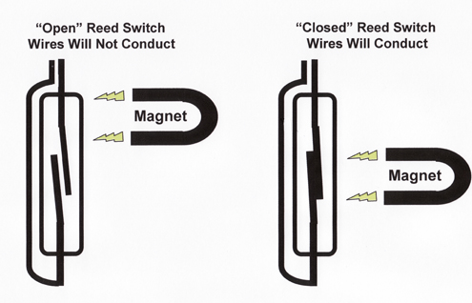

Figure 1 Reed Magnetic Switch (15)

Just the same as with the monitor for elderly users a Raspberry Pi will be used here to connect to the door sensors. Once the wires from the Sensor is connected to the Raspberry Pi it will need to be coded in C to receive the signal coming from the sensors and be sent to the database to alert the user of the situation.

## Conclusion

This chapter covered the research done on existing applications out there, such as similar applications to the one that I will be developing. Also discussed were all the technologies, scripting languages and software I will be using in the implementation of my project. The last thing that was discussed was the research on the technologies involved in developing the raspberry pi with the monitor attached to it for the elderly and the door sensor units that are needed to identify if a door does not open for a period of time.

# Design Methodologies

## Introduction

In this chapter a description of the high level design of this system will be demonstrated as use cases and the methodology used to design the project with.

## Project Methodology

Selecting a project methodology is a very important decision to make from the beginning of the project. There are many methodologies that are available such as Agile Unified Process, Scrum, Iterative and Waterfall to name a few. After doing some review the Iterative model was chosen. The main reasons for choosing the iterative model are as follows:

* **Discover Problems Easier: -** There is nothing worse than setting near the end of a project to have to find out that you have discovered a massive design problem and you are running out of time. The joy of the Iterative model is that you can discover design problems early on as you build the application in increments. This means that you don’t go ahead and build the whole application from start to finish without checking anything. The application is built in units, as you get one stage done first before moving on.
* **Getting Great Feedback: -** After each of the incremental stages is complete you can set about testing it with real users. This information that is accumulated from this can be vital to the improvement of your application. Paper prototyping is all well and good but it has its limits as the user has to use a lot of their imagination. So for the user to be able to feel and see a stage of the application done can go a long way.

### Iterative Model

Iterative design is “Learning by completing” (16)

It is basically an approach to building software that the whole process is done in several iterations. Each iteration is a mini project in its own self.

Within side these mini projects there are always four processes that take place and these are

* The requirements: - This basically indicates that a list of all the requirements for the project is laid out. The requirements should include the behaviour and a structured documentation of the system.
* The design: - This is where the software engineer develops a solution.
* The coding: - The development of the actual application is performed here. IT is done by writing code, documenting the code and finally debugging the code.
* The testing: - The testing phase is where internal people can test the part of the project that was completed by you. It is not yet released to the public for testing until the final product is completed whole (17).

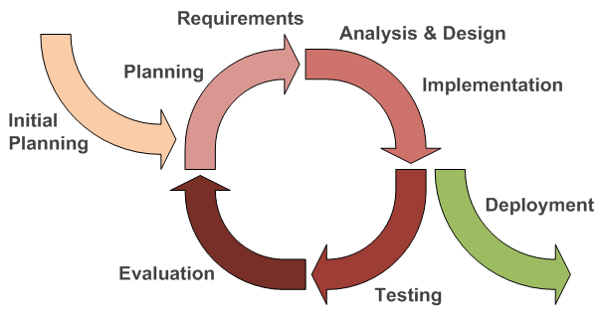

Figure 2 Iterative Model (18)

At the start of each major project the whole design of the project is divided up into small mini projects to be completed before moving on to the next. So as you can see from the above diagram each mini project is iterated through implementing each process until the end of the project is reached and it is released for deployment.

## Use Case

This section of the document deals with the use cases for my project. What will be shown is what interactions the user will be having from an end users point of view. The use case diagram will be divided up into smaller diagram that will gradually get larger as they go along as the final diagram of the whole project is overwhelming at first. A use case diagram usually consists of an actor that can be either human or a system. Then that actor can interact with tasks that lead the actor down certain paths. Below you will see my diagrams of my use cases and along with these I will be providing a small description explaining each one.

### Registered User Login

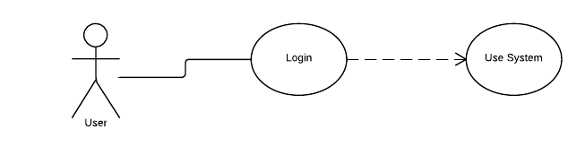

Figure 3 Use Case Registered User Login

Figure 3 above shows the high-level use case diagram used for representing the flow of events when a registered user logs into the application.

### Unregistered User

Figure 4 Use Case User Registration

Figure 4 above shows the high-level use case diagram used for representing the flow of events when an unregistered user registers for the application.

### Home Screen Interaction

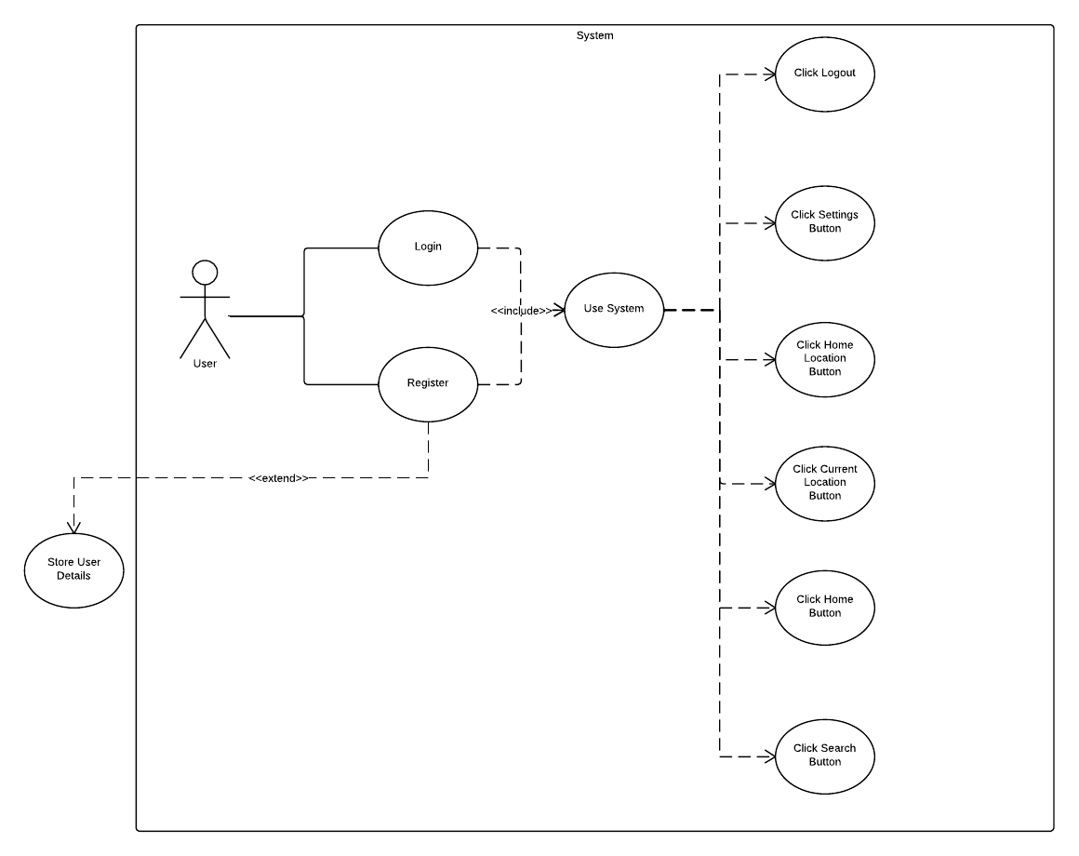

Figure 5 Use Case Home Screen Navigation

Figure 5 above shows the high-level use case diagram used for representing the flow of events when a user navigates through the home screen clicking on all the available links.

### Settings Screen Interaction

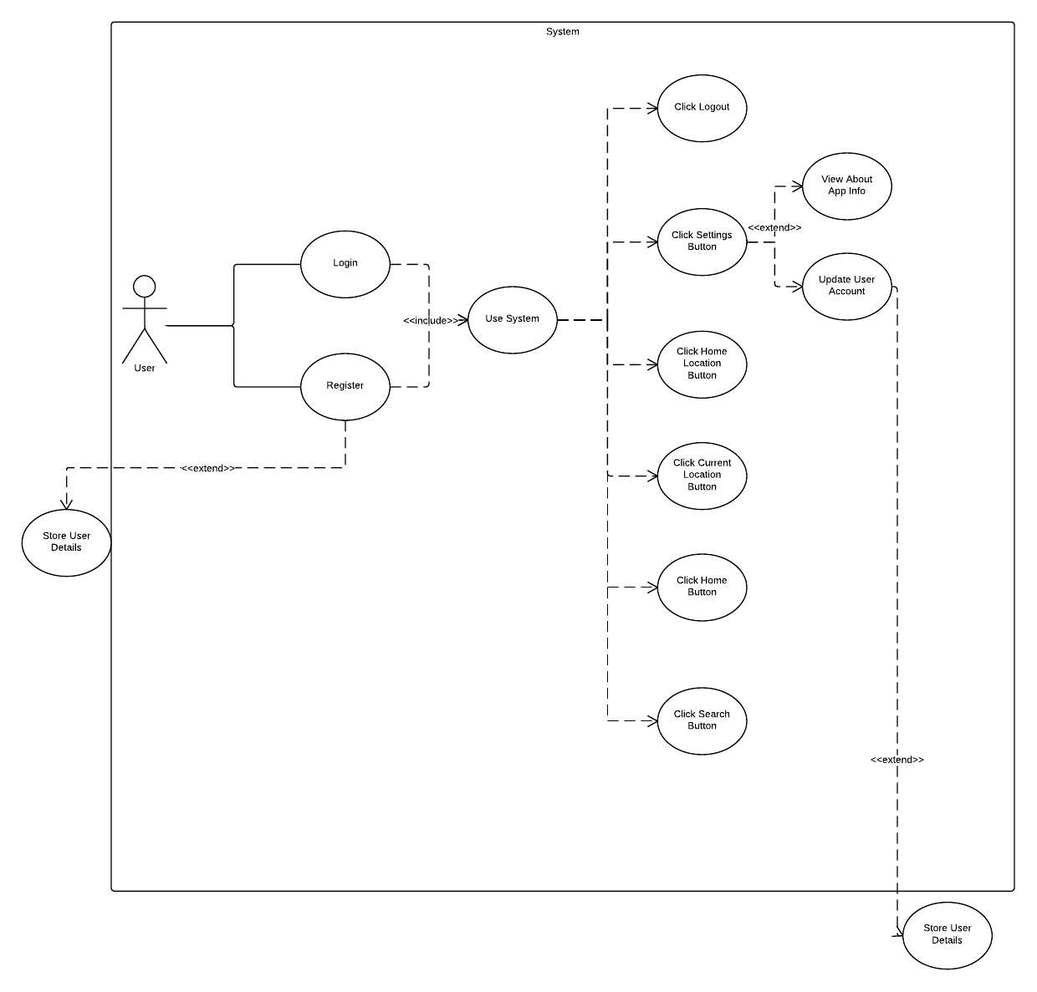

Figure 6 Use Case Settings Interaction

Figure 6 above shows the high-level use case diagram used for representing the flow of events when a user navigates through the settings, viewing the info and updating their account.

### Home Button Interaction

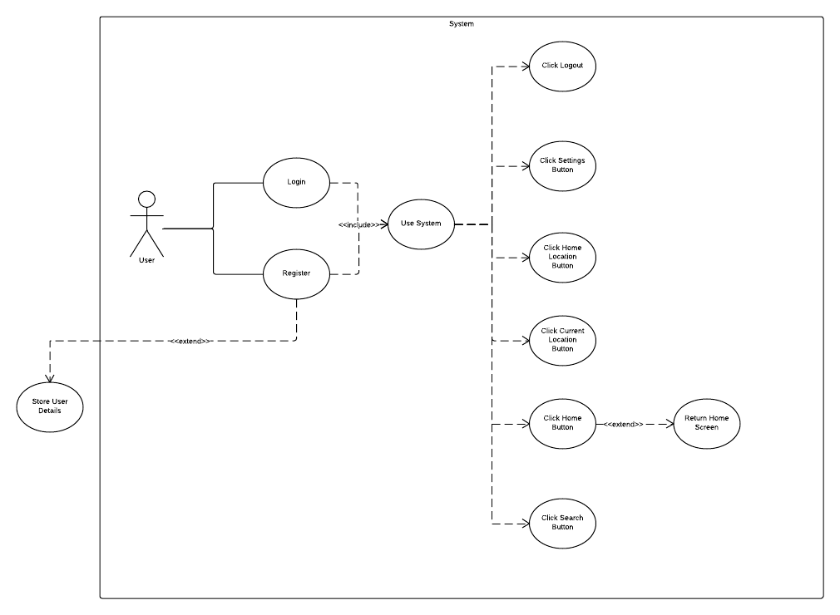

Figure 7 Use Case Home Button Interaction

Figure 7 above shows the high-level use case diagram used for representing the flow of events when a user interacts with the home button.

### Search Button Interaction

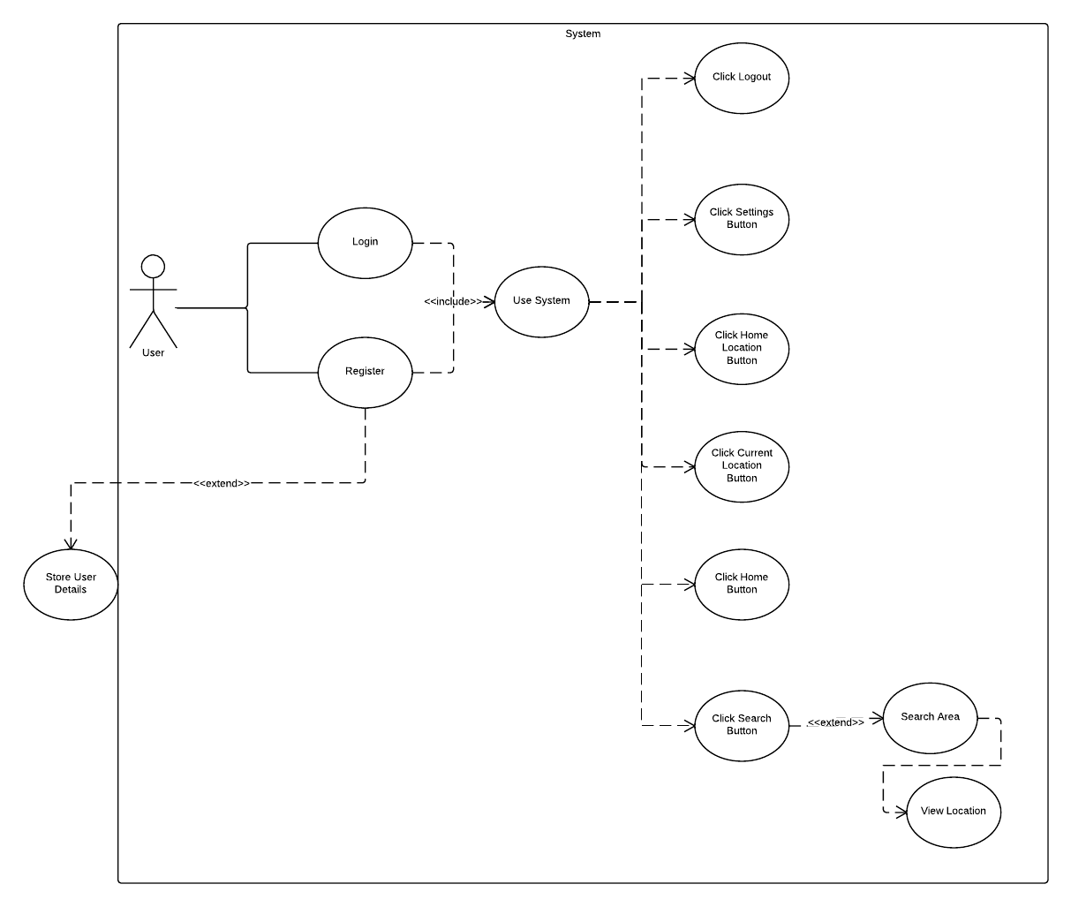

Figure 8 Use Case Search Button Interaction

Figure 8 above shows the high-level use case diagram used for representing the flow of events when a user wants to search for a location.

### Home Location Interaction

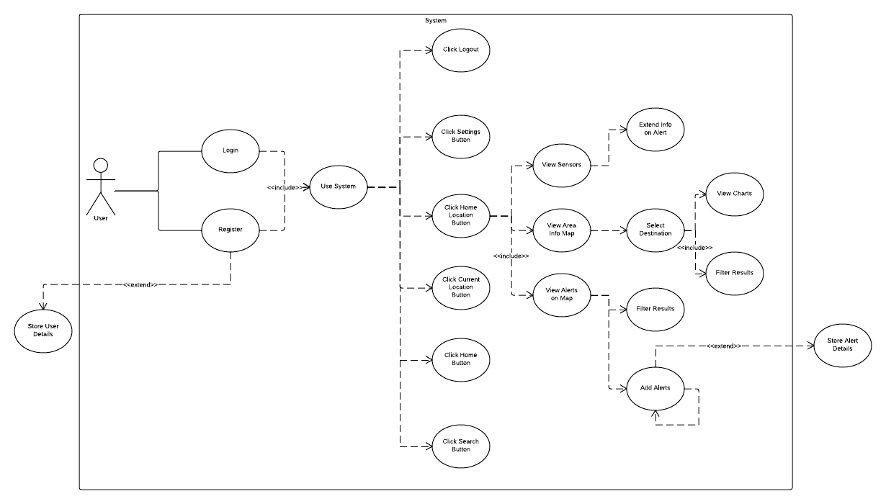

Figure 9 Use Case Home Location Interaction

Figure 9 above shows the high-level use case diagram used for representing the flow of events when a user interacts with their home location features such as viewing and posting alerts in the map provided.

### Current Location Interaction

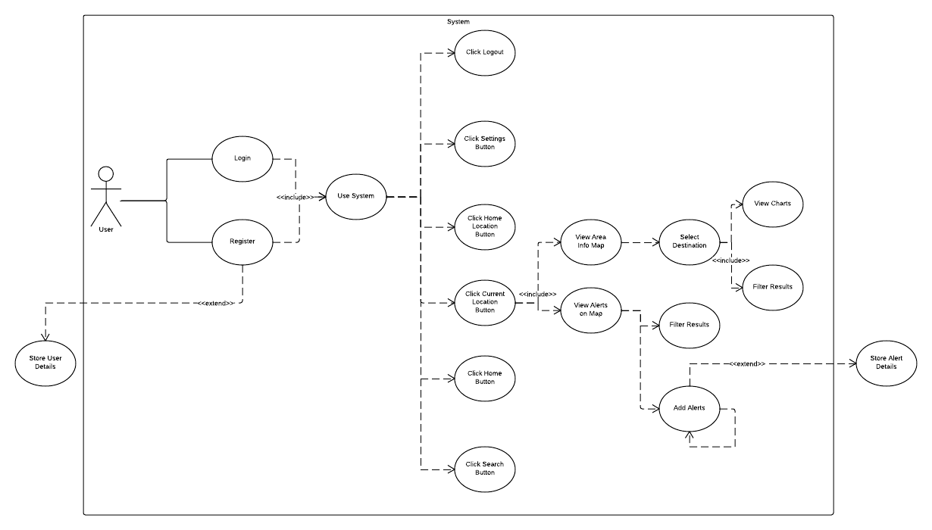

Figure 10 Use Case Current Location Interaction

Figure 10 above shows the high-level use case diagram used for representing the flow of events when a user interacts with their current location features such as viewing and posting alerts in the map provided.

### Monitor and Raspberry Pi Interaction

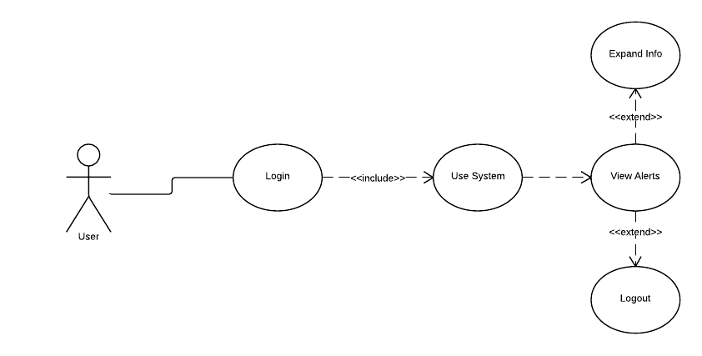

Figure 11 Use Case Raspberry Pi and Monitor Interaction

Figure 11 above shows the high-level use case diagram used for representing the flow of events when an elderly user interacts with the monitor that is installed in their home.

## UML Activity Chart

This section of the document contains some UML Activity Diagram. When it comes to the coding stage of the project these activity diagrams will be very useful as they will show the basic flow and they can show the iteration of the code throughout the project. The section will contain the following diagrams:

* Login
* Registration
* Post Alert
* Alerts on Monitor
* Door Sensors

### Registration

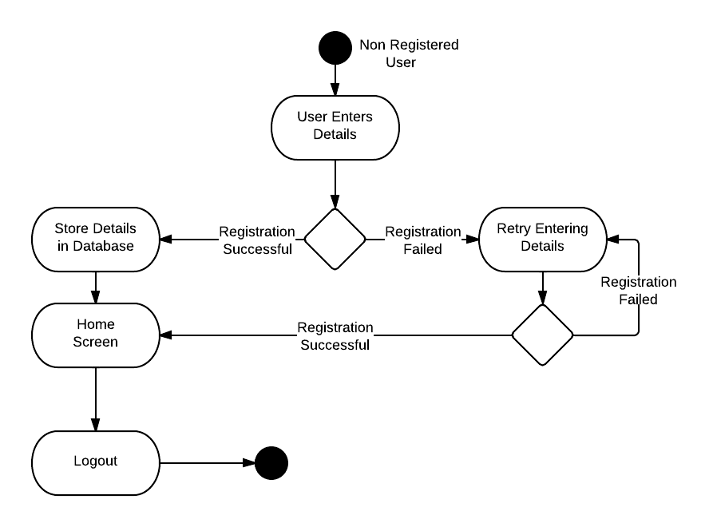

Figure 12 Activity Diagram Registration New User

The above diagram illustrates the process a new user has to go through to register for the application. When the user wants to register they need to fill out the form. The application then checks to see if the details that the user entered in are correct. If they are not they are told the error and then asked to retype the details. If they are their information is saved on the database and then the user is brought to the home screen.

### Login

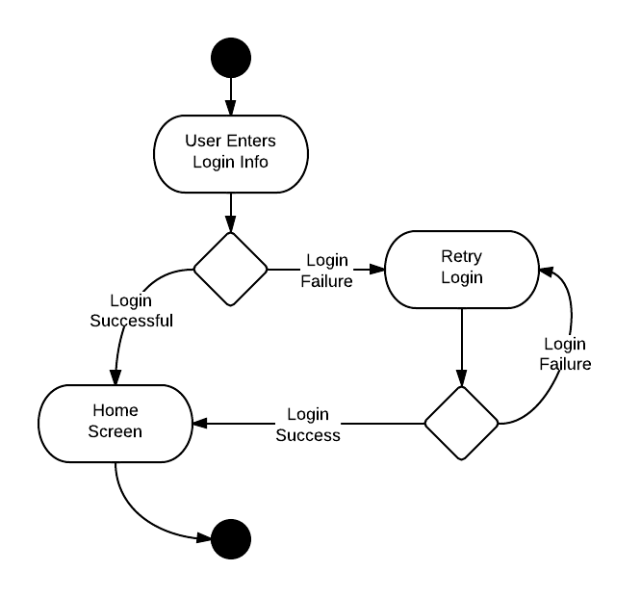

Figure 13 Activity Diagram User Login

In the above diagram it shows what the user has to go through to login to the application. The user enters in their login credentials such as username and password. The application then queries the database to see if the user’s credentials match to the ones that are stored in the database. If they are not successful they will be prompted to login again. But if they are successful they will be brought to the home screen to use the application.

### Post Alert

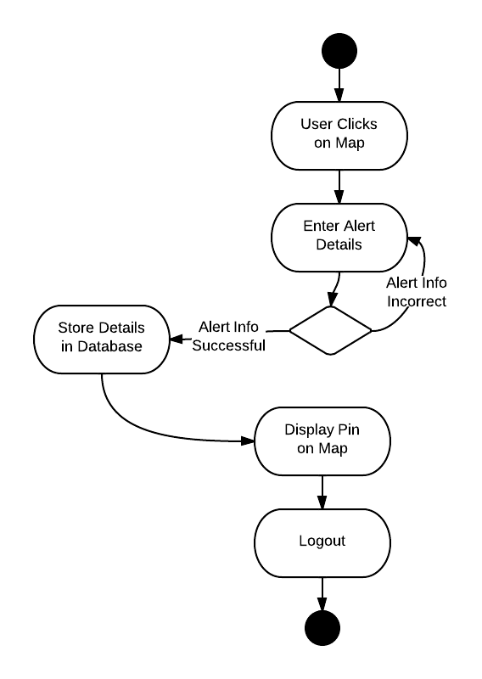

Figure 14 Activity Diagram User Posting Alerts

In the above diagram the user click on a location on the map provided. A dialog bog will pop up asking them to type in the details of the alert that they want to report. The application will then check to see if the information provided matches the requirements. If they don’t the user will be prompted to retry entering in the details. If the user is successful in their attempt to post an alert the details will be stored on the database. Then the user will be brought back to the map screen with a pin placed on the location that they clicked on earlier.

### Alerts on Monitor

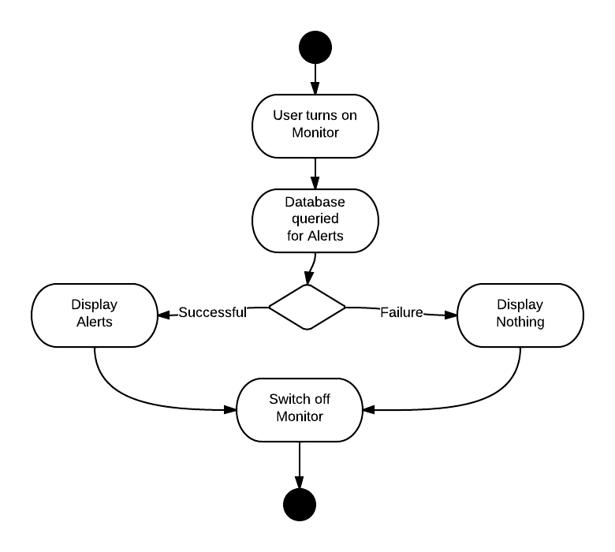

Figure 15 Activity Diagram Alerts Displaying on Monitor

In the above diagram the user who has the monitor installed in their home will be able to turn it on. Once on the raspberry pi will query the database to retrieve all the recent alerts for that area and display them on the screen. If there have not been any alerts for the given area yet the screen will display text explaining this to the user. If the query does find some alerts they will be displayed on the screen for the user to view and observe.

### Door Sensors

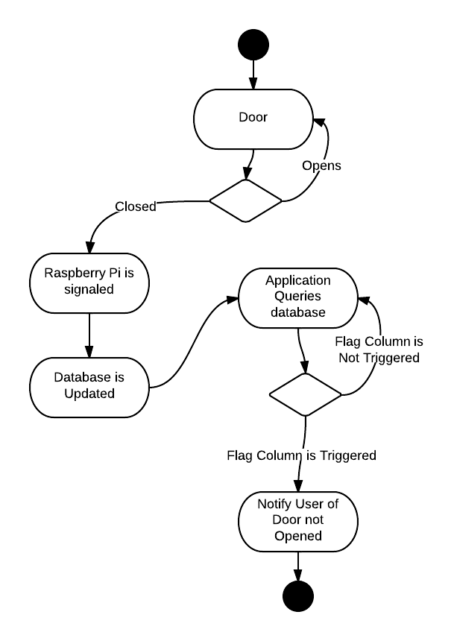

Figure 16 Activity Diagram Door Sensors

In the above diagram you can see the process that is involved with the door signals sending signals back to the database and then to the application. If the user’s door has not been opened for a period of time, a signal will be sent to the raspberry pi to send back to the database. Every couple of minutes the application will be continuously checking the trigger column in the database and once that column is triggered the user will be notified of the alert.

## User Interface Design

When developing an application it is important to cater for everyone. Such as people with bad eye sight, people of all ages and so on. This is done by identifying all the usability problems in the users interface design. I man called “Jakob Nielson” came up with a set of rules that will help you identify any usability problems (19). His list of rules is as follows:

* **Visibility of system status: -** This means that you always need to keep the user up-to-date with what is going on within the application. You don’t want a user getting lost within the application. By giving the user feedback at appropriate time to help them. An example would be having a help button icon on each page explaining how is page is operated. (19)
* **Match between system and the real world: -** The application should represent real world objects and icons. Such as a house icon would represent the home screen, the play button from remote would represent play on application (19).
* **User control and freedom: -** Users may get lost from time to time and you need to let the user be able to retreat back with a clearly marked icon such as an undo button (19).
* **Consistency and standards: -** The whole way through the application the writing styles and size should stay the same. You don’t want the user trying to adjust to loads of different views (19).
* **Error Prevention: -** When designing the application it is best to have no errors prone conditions, but if you can’t avoid them it is best to include a confirmation message before they commit to the act (19).
* **Recognition rather than recall: -** Let the user recognise the icons on each page. Don’t have them trying to recall everything from one page to another (19).
* **Flexibility and efficiency of use: -** Add in accelerators that could speed on the process for expert users but it may be hidden for novice users (19).
* **Aesthetic and minimalist design: -** Try to limit the amount of information the user has to take in. There should not be any dialog that may be irrelevant or rarely needed (19).
* **Help user’s recognize, diagnose and recover from error: -** When an error message is presented to the user it should be written in plain text for them to understand. They don’t need to try and work out code error messages (19).
* **Help and documentation: -** It is always good to provide some documentation for the user that explains everything about the system (19).

During the design of this application the above guidelines were followed as you will see in the prototypes and the final product.

Neilson’s Heuristics

## Horizontal Prototyping

The first prototyping is horizontal; this type of prototype gives a broad overview of the whole application or system. It focuses more on the user interactions rather than the low-level system functionality. You basically have three types that you can use and these are Low-fidelity, medium fidelity and high fidelity. The low fidelity is paper prototypes where all the screens that the user will be interacting with are drawn up. The medium fidelity is done using some type of low end software such as paint or something similar where the user has some interaction, something that will let them navigate between pages. The high fidelity prototype is built with software that is close to the one used for the finished product. It will give the user as close to a feel of the finished prototype as they will get.

For this application the low fidelity prototype was chosen. Each screen of the application was drawn out on paper and can be viewed below.

### Prototype Testing

The low fidelity prototype when completed will be tested on users that meet the appropriate user profile. Since the application is about keep neighbourhoods safe and informing the local communities the user profile will be focusing on people that are involved in neighbourhood watch schemes of all ages. Another point to mention is that since the second part of the project will be focusing on elderly people, the testing will be first conducted on neighbourhood watch associates who will participate in testing the application. Then following that elderly people will participate in testing the prototype of the monitor displaying the alerts to them.

The users that are participating in the testing of the prototypes will be given a walkthrough of the whole application before been shown the paper prototypes along with a questionnaire. The users will go through each image of the screens and try and mimic the involvement with the application. They will then jot down their findings of how they evaluated the application. Below you will see all the paper prototypes for the application:

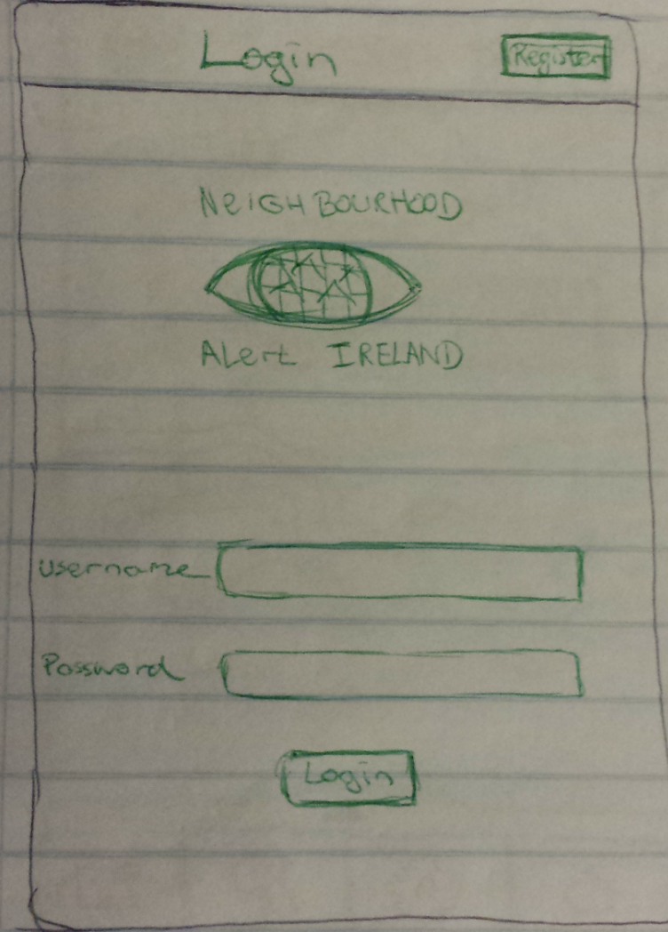

Figure 17 Login Screen

The above screen is what the user will see when they open up their application. They will fill in their username and password to login. If they are not registered they will need to click the register button at the top of the screen.

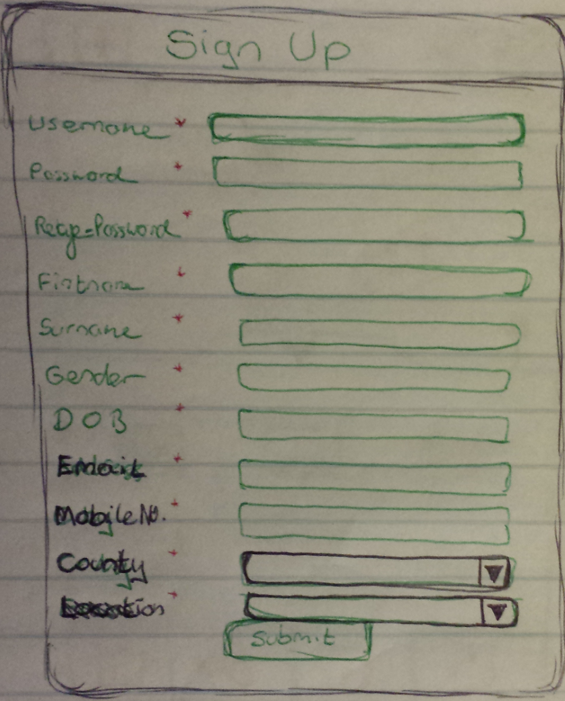

Figure 18 Registration Screen

The above screen is what the user will see when they want to register for the application. The user fills in all the fields with their information.

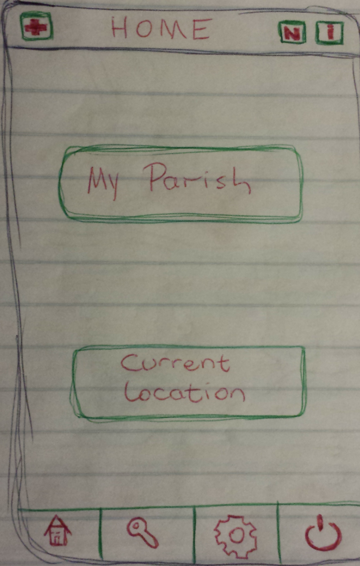

Figure 19 Home Screen

This will be the users home screen that they can get to at any time by clicking on the home button located at the bottom of the application.

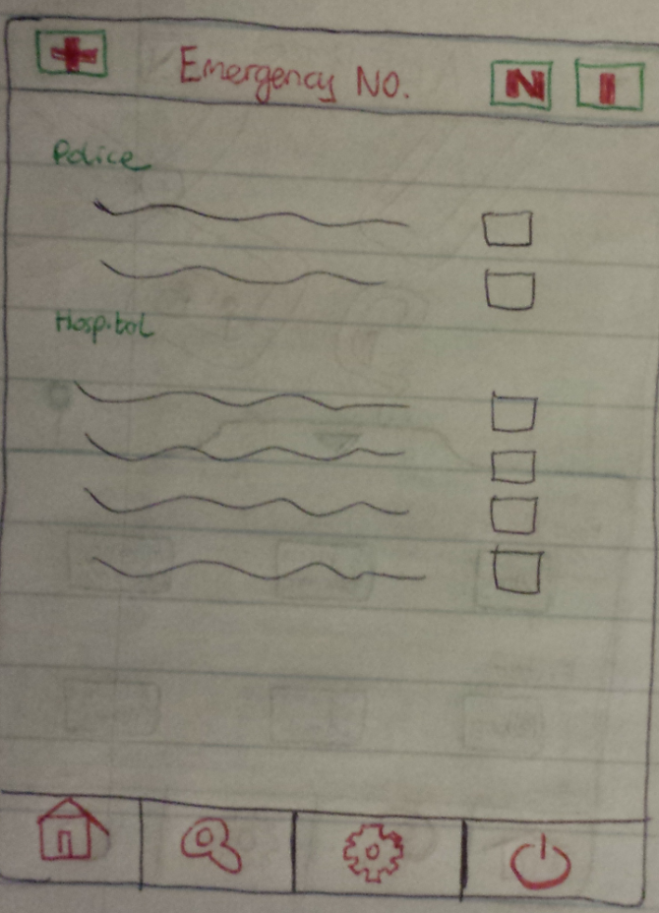

Figure 20 Emergency No. Screen

If the user clicks on the emergency contact numbers button located at the top left of any screen they will be brought to here where they can call any local emergency number available.

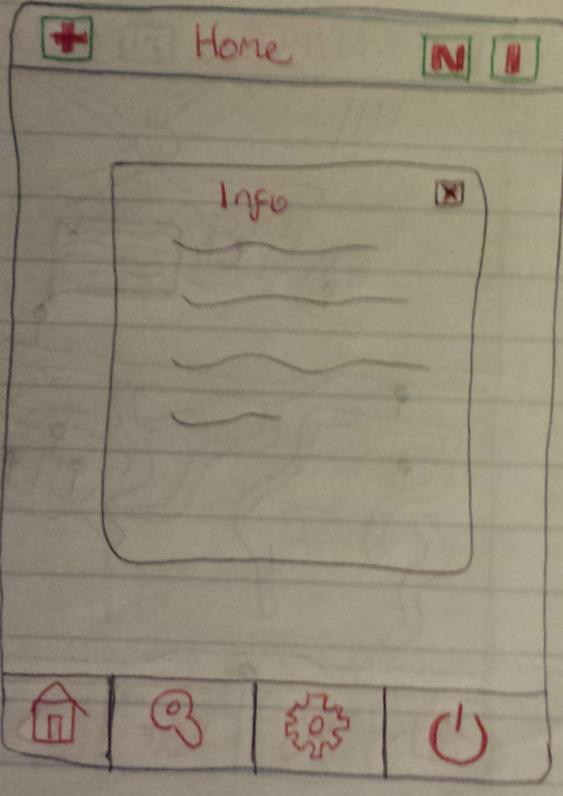

Figure 21 Screen Info Screen

If a user can’t come to terms with what to do on a page or is confused they can click on the info button located on all screen. The button can be found on the top right of the screen and when clicked will open up a dialog box explaining what the page is about and how to navigate it.

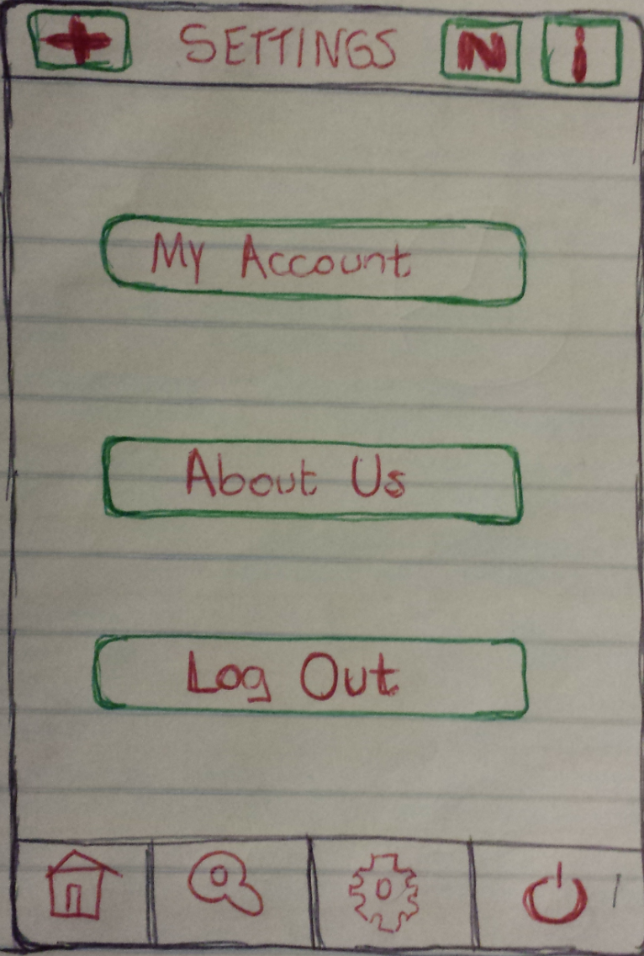

Figure 22 Settings Screen

If a user needed to change some data on their account they can do so by clicking on the my account button located in the settings. The settings can be accessed by clicking on the cog button situated on the bottom menu of the screen.

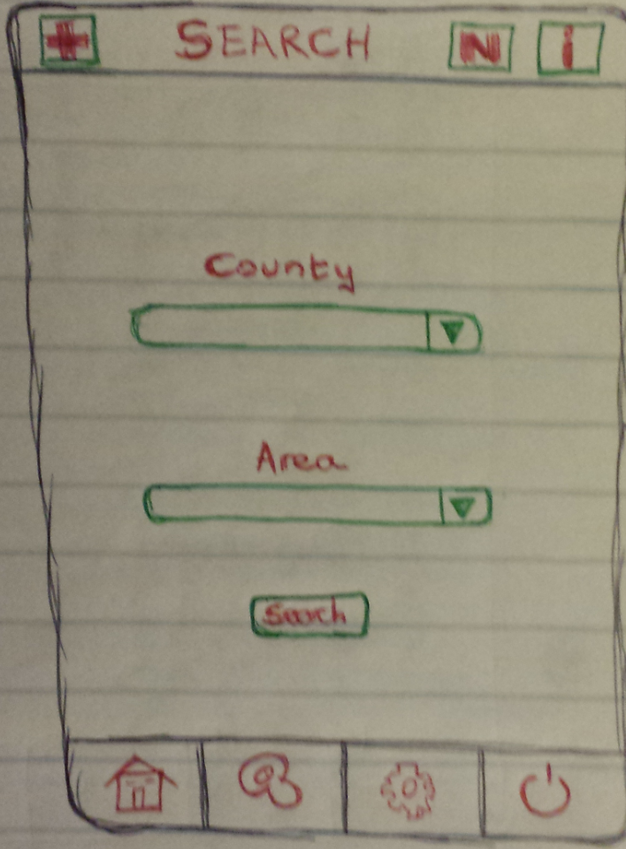

Figure 23 Search Screen

If a user needed to find a particular location they can do so by clicking the search button located on the bottom menu of all screens.

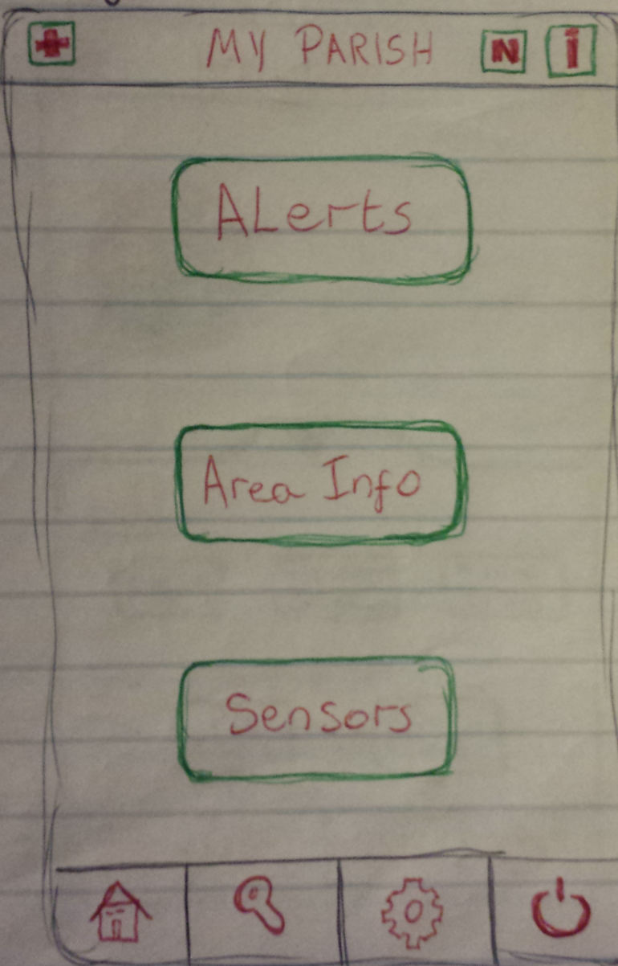

Figure 24 Home Location Screen

When a user clicks on their home location button they will be presented with the following options. The first one will bring them to a map of their home location filled with alerts on it. The second button will bring up a map and when clicked on certain area will display local information about the place in graphs and text. The last button will display all the information of any sensors the user has installed.

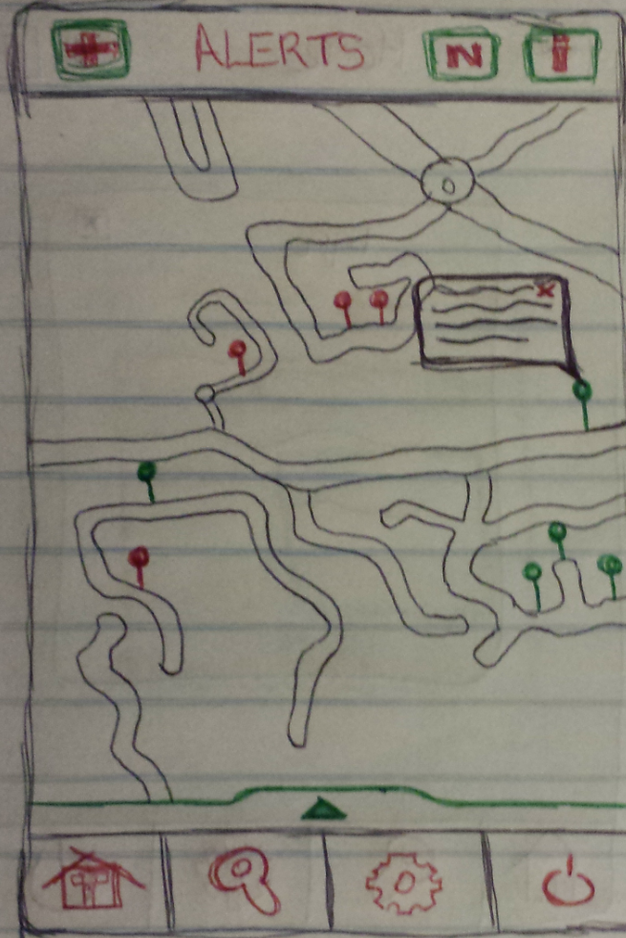

Figure 25 Alerts Screen

This is the map that the user will be presented with. On this map the user can click on a location and place a pin to report an alert in that area. Also the user can view alerts already posted up by clicking on a pin already placed.

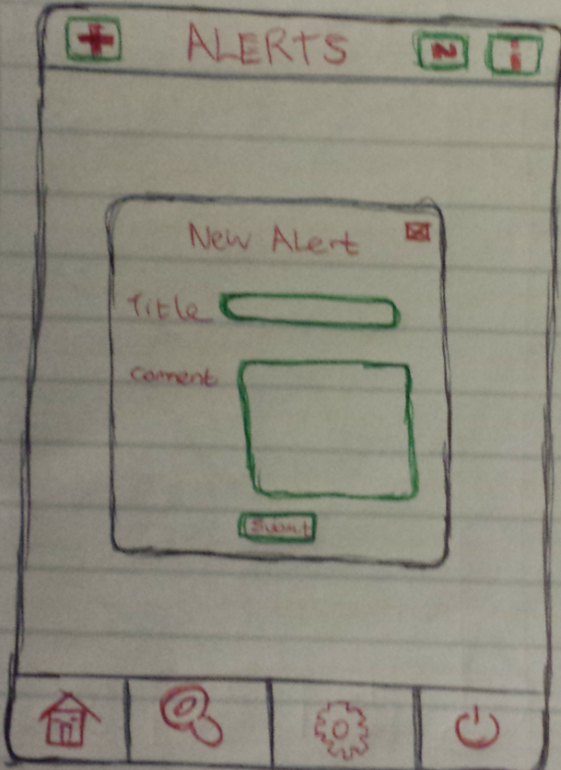

Figure 26 New Alert Screen

If a user wants to post a new alert onto the application this is the screen that they will be presented with. They will just need to fill it in and click on the submit button.

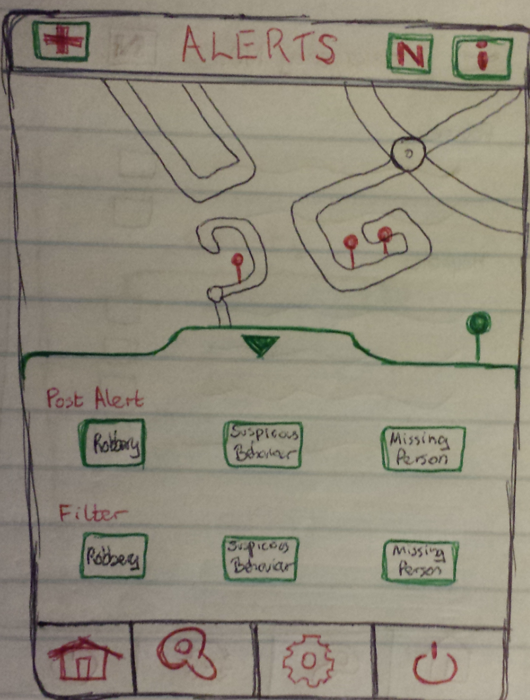

Figure 27 Alerts Menu Screen

On the alerts screen the user can open a menu button that will allow then to filter out results for alerts.

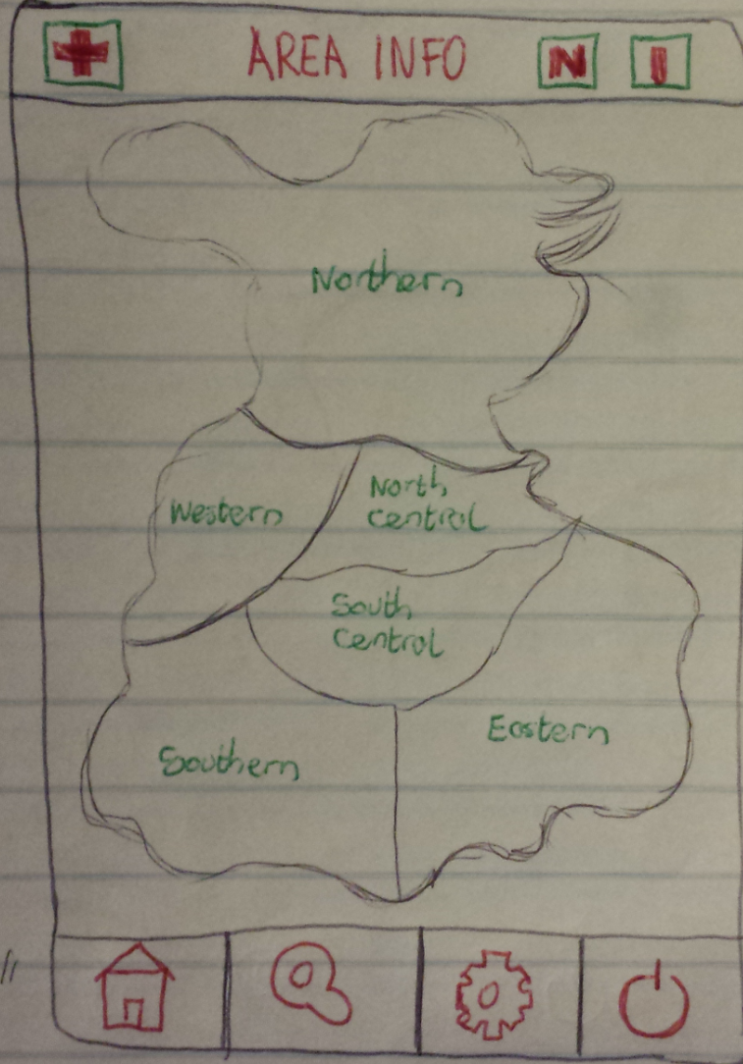

Figure 28 Area Info Screen

This is an example of the map a use will be faced with when they click on the area info button. If a user clicks on one of the area a new screen pops up shows more details about that area.

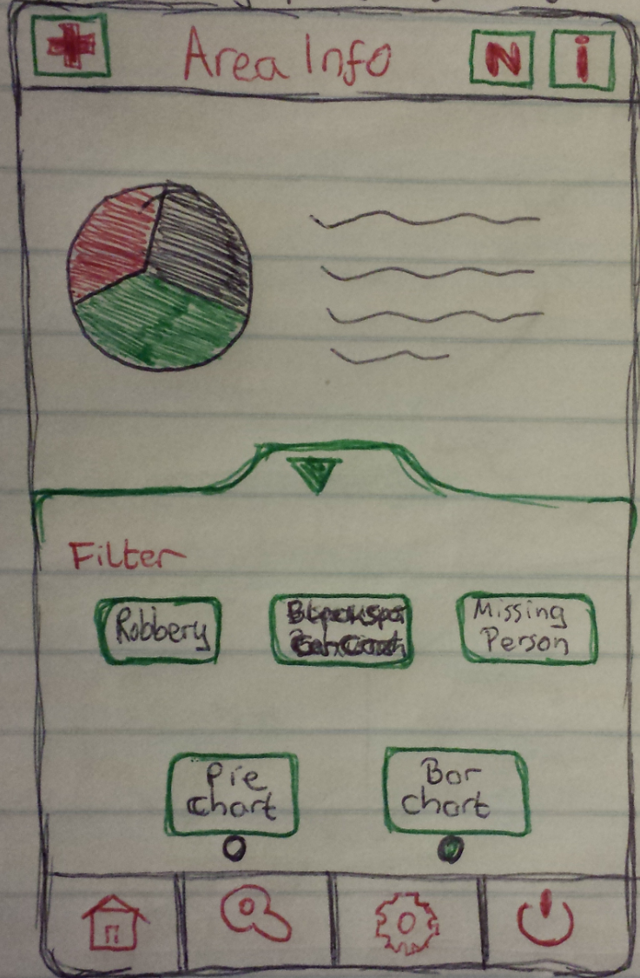

Figure 29 Area Info Menu Screen

These are the options the user has when they click on a location on the map of the area info screens. They can view the information in different graphs such and pie chart and bar chart. They can also filter out any of the search results they see.

### Questionnaire

Here is a list of all the questions that the users of the mobile application got asked during the prototype testing phase:

1. Name?
2. Age?
3. Sex?
4. Do you own a smart phone?
5. What do you think of the concept of the mobile app?
6. Do you think that it is an improvement on the current system?
7. Would you use this mobile app?
8. Do you think it would be easy to navigate?
9. Is the layout correct?
10. Are the button sizes correct?
11. Is the text easy to see and readable?
12. Is the emergency contact section helpful?
13. Is there anything you would change about the app?
14. Rate the login page (Good/Ok/Bad)
15. Rate the Registration page (Good/Ok/Bad)
16. Rate the Home page (Good/Ok/Bad)
17. Rate the Emergency Contact page (Good/Ok/Bad)
18. Rate the Info page (Good/Ok/Bad)
19. Rate the Search page (Good/Ok/Bad)
20. Rate the Settings page (Good/Ok/Bad)
21. Rate the Alerts page (Good/Ok/Bad)
22. Rate the Post Alert page (Good/Ok/Bad)
23. Rate the Alert Menu page (Good/Ok/Bad)
24. Rate the Area Info page (Good/Ok/Bad)
25. Rate the Area Info Menu page (Good/Ok/Bad)
26. Would you feel safer if you had this mobile application on your phone?

Here is a list of all the additional questions that the elderly users got asked during the prototype testing phase:

1. Name?
2. Age?
3. Sex?
4. Do you own a smart phone?
5. What do you think of the concept?
6. Would you be willing to get the raspberry pi and monitor installed in your house?
7. What would you like to see on the screen?
8. How much interaction would you like with the monitor?
9. What is your opinion on the door sensor?
10. Would you install it in your house?
11. Would you feel safer if you had the raspberry pi installed in your house?

### Test Findings

This is the feedback that I obtained from the users:

|  |  |  |  |
| --- | --- | --- | --- |
| Task | User | Response | Suggestions |
| Age | Susan  Mark  Mary  Ciaran | 29  45  36  22 | -NA  -NA  -NA  -NA |
| Do you own smart phone? | Susan  Mark  Mary  Ciaran | Yes  Yes  Yes  Yes | -NA  -NA  -NA  -NA |
| What do you think of the concept of the mobile app?  (Good/Ok/Bad) | Susan  Mark  Mary  Ciaran | Good  Good  Good  Good | -NA  -NA  -NA  -NA |
| Do you think that it is an improvement on the current system? | Susan  Mark  Mary  Ciaran | Yes  Yes  Yes  Yes | -NA  -NA  -NA  -NA |
| Would you use this mobile app? | Susan  Mark  Mary  Ciaran | Yes  Yes  Yes  Yes | -NA  -NA  -NA  -NA |
| Do you think it would be easy to navigate? | Susan  Mark  Mary  Ciaran | Yes  Maybe  Yes  Yes | -NA  -Need to see working application  -NA  -NA |
| Is the layout correct? | Susan  Mark  Mary  Ciaran | Yes  Maybe  Yes  Yes | -NA  -It seems to be so far.  -NA  -NA |
| Are the button sizes correct? | Susan  Mark  Mary  Ciaran | YES  YES  YES  YES | -NA  -NA  -NA  -If they stay the same as they are now yes. |
| Is the text easy to see and readable? | Susan  Mark  Mary  Ciaran | YES  Maybe  Maybe  Yes | -NA  -Text on buttons may be a bit small.  -A small bit bigger  -NA |
| Is the emergency contact section helpful? | Susan  Mark  Mary  Ciaran | Yes  Very  Yes  Yes | Great Idea  NA  NA  NA |
| Is there anything you would change about the app? | Susan  Mark  Mary  Ciaran | Yes  Yes  Yes  No | Maybe the colour.  What I mentioned earlier.  Text a bit bigger.  NA |
| Rate the login page (Good/Ok/Bad) | Susan  Mark  Mary  Ciaran | Good  Good  Good  Good | NA  NA  NA  NA |
| Rate the Registration page (Good/Ok/Bad) | Susan  Mark  Mary  Ciaran | Good  Ok  Ok  Good | NA  Too many questions.  Less questions.  NA |
| Rate the Home page (Good/Ok/Bad) | Susan  Mark  Mary  Ciaran | Good  Good  Good  Good | NA  NA  NA  NA |
| Rate the Search page (Good/Ok/Bad) | Susan  Mark  Mary  Ciaran | Good  Good  Good  Good | NA  NA  NA  NA |
| Rate the Settings page (Good/Ok/Bad) | Susan  Mark  Mary  Ciaran | Good  Good  Good  Good | Nice and simple  NA  NA  NA |
| Rate the Emergency Contact page (Good/Ok/Bad) | Susan  Mark  Mary  Ciaran | Good  Good  Good  Ok | NA  NA  NA  Maybe a better layout of numbers. |
| Rate the Info page (Good/Ok/Bad) | Susan  Mark  Mary  Ciaran | Good  Good  Good  Good | NA  Good Idea  Make sure text is big.  NA |
| Rate the Alerts page (Good/Ok/Bad) | Susan  Mark  Mary  Ciaran | Good  Good  Good  Good | Nice layout.  NA  NA  Like the pins idea. |
| Rate the Alerts Menu page (Good/Ok/Bad) | Susan  Mark  Mary  Ciaran | Good  Good  Ok  Good | NA  Nice idea for menu.  Make sure everything is visible.  NA |
| Rate the Post page (Good/Ok/Bad) | Susan  Mark  Mary  Ciaran | Good  Good  Good  Good | Nice and simple.  NA  NA  NA |
| Rate the Area Info page (Good/Ok/Bad) | Susan  Mark  Mary  Ciaran | Good  Good  Good  Good | NA  Great Idea.  NA  NA |
| Rate the Area Info Menu page (Good/Ok/Bad) | Susan  Mark  Mary  Ciaran | Good  Good  Ok  Good | NA  NA  Same as last menu question.  NA |
| Would you feel safer if you had this mobile application on your phone? | Susan  Mark  Mary  Ciaran | Yes  Yes  Yes  Yes | Would put my mind at ease.  NA  Very safe.  NA |

Second test findings associated with the raspberry pi’s, door sensor and the monitor.

|  |  |  |  |
| --- | --- | --- | --- |
| Task | User | Response | Suggestions |
| Name? | Cait  Joe | Cait  Joe | NA  NA |
| Age? | Cait  Joe | 86  92 | NA  NA |
| Do you own a smart phone? | Cait  Joe | No  No | NA  NA |
| What do you think of the concept?  (Good/Ok/Bad) | Cait  Joe | Good  Good | Excellent Idea.  NA |
| Would you install a raspberry pi in your house? | Cait  Joe | Yes  Maybe | NA  What would need to be done?  Would it cost much? |
| What would you like to see on the screen? | Cait  Joe | Alerts, maybe map.  Alerts for my area. | NA  NA |
| How much interaction would you like with the monitor? | Cait  Joe | Minimal  Not Much | Not good with technology so not much.  NA |
| What is your opinion on the door sensors?  (Good/Ok/Bad) | Cait  Joe | Good  Ok | NA  Does eircom phone watch not do this |
| Would you get the sensors installed? | Cait  Joe | Yes  No | Would it cost much?  NA |
| Would you feel safer if you had the monitor installed in your house? | Cait  Joe | Yes  Yes | NA  Would make me relax more knowing I can view alerts about my area. |

## Database Design

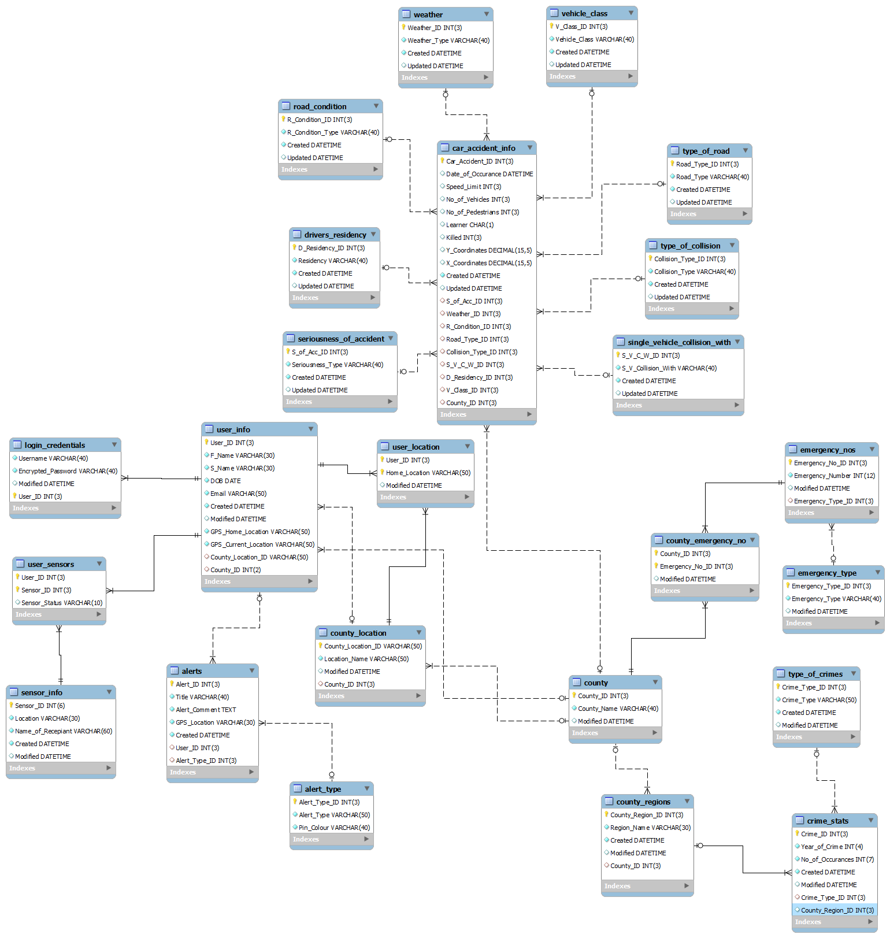

Figure 30 Full ERDiagram

In the above diagram you can see the whole entity relationship diagrams (ERD) which shows the relationships between all the tables that make up the application.

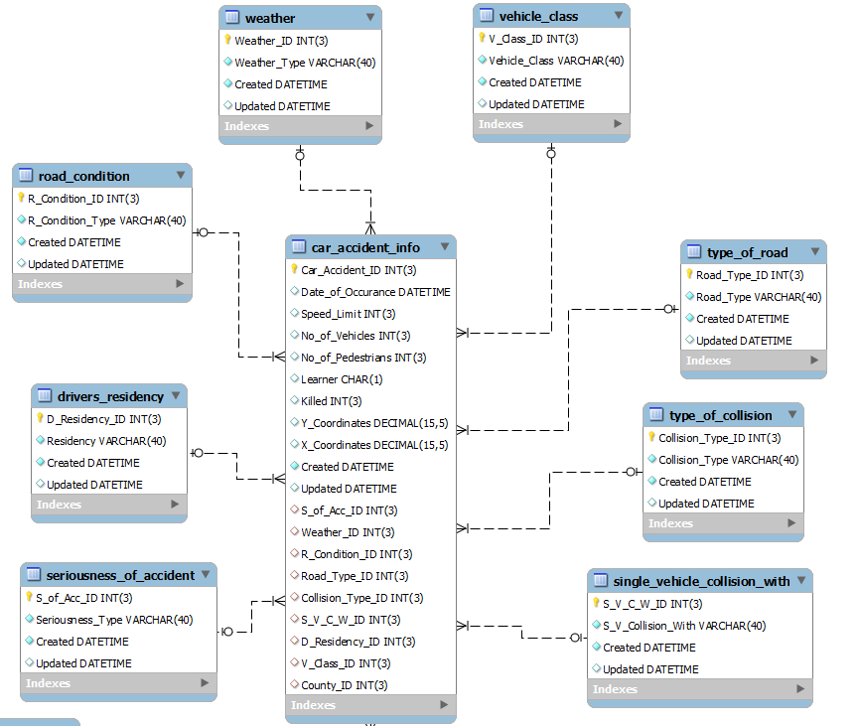

Figure 31 First ERD Close up

The above diagram represents the data that is coming from the road safety authority (RSA). The name table car accident info will hold all the data that will be updated regularly. The other eight tables hold all the data that will not be changed. The excel file that the RSA publish each year will be drafted into the car accident info table. The foreign keys will be populated by the surrounding tables.

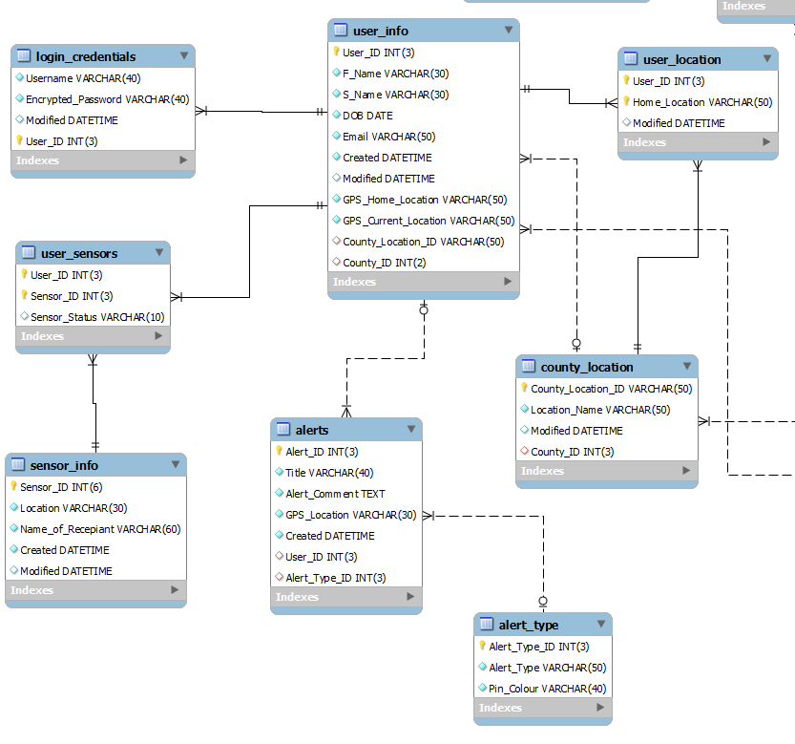

Figure 32 Second ERD Close up

The above section of the ERD firstly shows the tables that store the entire user’s information. The type of information that it stored in these tables include the users name, their username and their password. Then you have got the tables that will store all the information about an alert that a user posts. These tables are called alerts and alert types and they hold information such as the type of alert, the location and what the alert was about.

The data for the door sensors for the elderly users are stored here. They are called the user sensors and the sensor info tables. This is where the data will be stored that will trigger the users mobile phone telling them that the door sensor has not been triggered for a long period of time. The last couple of tables that are shown above are the user location and the county location tables. These store all the locations that are situated in each county and the location of the user that will be used as their home location.

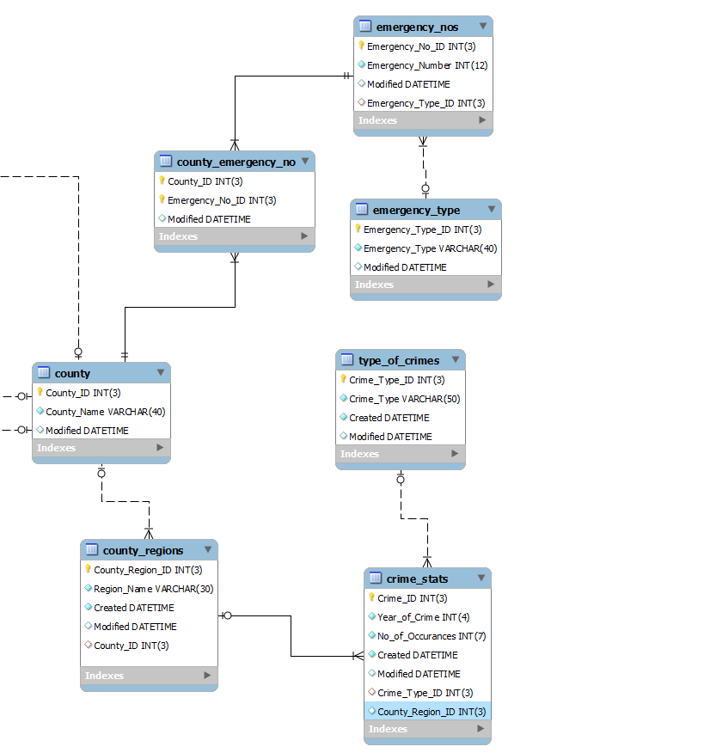

Figure 33 Third ERD Close up

The last section of the ERD above firstly houses the table county that stores all the names of the countries around Ireland. Then you have the tables that store all the data that is taken from the central statistics office (CSO). The first table is the county regions table; the CSO divide up the county regions a bit different than they are originally laid out such as Dublin is divided up into six regions.

The next one up is the types of crime table, this table stores all the different types of crimes such as burglary, drugs or kidnapping. Then the crimes stats table that will store all the information about each crime such as how many offences took place in a certain year. The last group of tables that are on the ERD are the emergency types table, the emergency number table and the county emergency table. These tables hold all the phone data for the emergency numbers all around Ireland. If a user needs to ring an emergency in, these tables will provide them with the information.

## Conclusion

This chapter has covered the design methodology that will be used on the application such as Agile. Also discussed was the use case diagram that shows what interaction the user will have on the application. The activity diagrams, the horizontal prototyping which included the diagrams and questionnaire and the last bit of information discussed was the database layout which included diagrams of the entity relationship diagram.

# Architecture and Development

## Introduction

In this chapter the system and software architecture will be detailed going through each level of the architecture. It then goes through the environments and languages chosen to develop the application. The chapter then details the development work that has already been done along with the vertical prototype.

## Architecture

### System Architecture

The systems that will be used for this project will be displayed in the diagram below. This type of diagram is useful for external people wanted to know how your whole system is connected and how it takes shape.

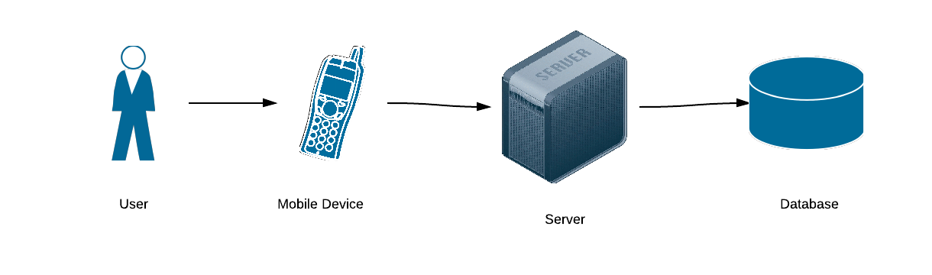

Figure 34 System Architecture

A three-tier architecture will be used for the implementation of the design. The front end that will be used will be the mobile device coded in C#. The middle tier that will be used will be an apache server coded using PHP. The backend tier will be the MySQL which will store all the persistent data for the system. The only layer of the application that will be available to the user will be the graphical use interface (GUI). The user will be able to store and edit data that is stored inside the database.

### Software Architecture

All of the software the will be used in this project will be displayed in the diagram below. This is useful as it give an overview of how all your software is connected and where it is located within the systems.

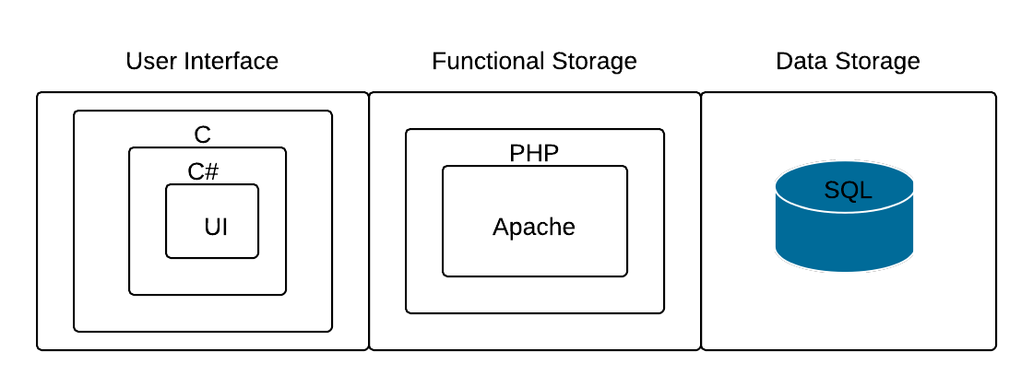

Figure 35 Software Architecture

In the above diagram you can see the three-tier architecture showing where all the pieces of software will be situated in the project. On the user interface which will be their mobile phone, they will have the compiled C# code running the application. Then in the middle tier which is the server which will be running Apache with PHP code attached to it, controlling all the requests. The last tier then will be the database which will have SQL scripts attached to it executing all the updates, queries and inserts into the tables.

## Environment

The environment that this application will be focusing on is all mobile phones. Firstly do the deployment to android phones will be the priority and then simply porting them to other operating systems after. The reasons for picking android over any other operating system is basically that it is easier to develop for and much easier for testing on.

The working environment that will be used to build the application will be Unity3D. This environment as chosen as it will give a challenge as it is a games engine and not built for building business applications. The other reason it was chosen is that is so easy to port to other platforms as soon as the application is built for one of them. With Unity3D all that is needed to be done for testing on android is to connect your phone and just build it onto it. This will make testing the application much faster and as a result will make fore faster development and changes.

MSQL workbench is being used to handle the database operations and wamp is being used to house the server and database in one single place for easy accessibility. Wamp gives a nice neat user interface to interact with which allows the user to start or stop the server with ease.

## Languages

The languages that come with Unity3D are C# and JavaScript. The one that was picked to develop this application was C# as I had self-thought it a few years ago for a computer games competition. For the talking between the application and the server will be PHP, this will execute all the commands sent from the application. Then once the application has successfully sent the data MySQL will be used to update, create or insert tables in the database. The coding on the raspberry pi’s will be done using standard C.

## Vertical Prototyping

This type of prototyping is a walkthrough of a single section of the application. Where horizontal focused on the whole application, vertical focuses on one aspect. The example that was conducted for this application was the user login system. To get this to work the login connection to the server and database will need to be set up and coded to handle to requests to the database. The user will enter in their login credentials, the server will look after the request and query the database to see if the credentials match. If they do, a request is sent back telling the application that it is ok and to let the user into the application home screen.

Testing for this prototype will be done after this report is done, so the findings that are recorded from the test will be documented in the final report.

## Work Done

The development work that has been done so far includes settings up the environments for the project such as the database, the server and the development software. The first thing that got developed was a rough development of all the screens of the application. A background was added for all the screens along with some buttons to help the user navigate along the pages. This was the basic development work that was done at the start of the project. All this code was developed using C# in Unity where there was just buttons added to each scene to help the user navigate between screens of the application.

The next thing that was developed was the database. This was done using MySQL workbench where MySQL is needed to code in. All the tables were created with their constraints attached to them restricting the user from adding unwanted data to the tables and to indicate which fields where housed the primary and foreign keys. The tables that had data in them and that data was not going to change over the course of the project was populated with data so fill up the tables a bit.

At the time of writing this report I am in the process of attempting to get my user registration working on the application. If this section of the application was to work it would prove that a connection from the application to the server and database was possible. Hopefully by the time the presentations come along this section will be complete and I can use it to demonstrate a vertical prototype.

## Conclusion

This chapter has covered the architecture of the project, explaining why this layout was picked including diagrams to help illustrate it. Also discussed was the environment picked, what languages was to be used, the vertical prototype and the work that has already been done on the project.

# Challenges, future work & Project Plan

## Introduction

This chapter will be delving into the challenges that have faced this project so far and the challenges that will be waiting ahead. Also all the future work that needs to be taken place along with the test, evaluation and project plan.

## Challenges

The challenges that have come up so far in this project are trying to source information that is available about past crimes and accidents. The original idea for the application was to have data already in the application for the user. Just so they don’t download the application and it is blank at first. At first An Garda Siochana were to provide past crimes that have happened in areas around Ireland. Information of this caliber has not been available for the public so far, such as the UK where is has been available to the public for some time now. I was not very hopeful of getting this information as the Garda are not reluctant to release this type of information. Alternative data was sought out by talking to the road safety authority (20) and the central statistics office (21).

Emails were sent to both authorities who responded in little to know time. The road safety authority send out a copy of their database in an excel page that covered the past six years of all accidents in Ireland. The central statistics office have recorded statistics about crimes on their website for people to download in excel sheets. The statistics cover the last five years. The remaining challenges that will be encountered will be taking a cluster of alerts in one area and shading it in on the map provided. The last challenge will be to get everything done in time for the deadline. This is being said as once the application is completed there is still two other projects to be done. These are programming a raspberry pi with a monitor connected to display alerts for elderly people in their homes and the second thing is connecting a sensor to a door that will trigger the database when that door hasn’t been opened for a period of time.

## Future Work

After this interim report is submitted there will be plenty still left of the project. The first thing will be to test the vertical prototype with users and change the application to mirror the results. Then the next part of the project will be to get the maps inside the screens for the users to interact with. The users will be able to click on a location on the map and add an alert to that location. Then finishing up the rest of the application which involves displaying alerts on the maps, shading in the maps where there has been a cluster of alerts and doing all the testing after the application is finished.

After the application is finished the next part of the project will be to program a raspberry pi with a monitor connected to display alerts for elderly people in their homes and then the last bit of the project will be to connect a sensor to a door that will trigger the database when that door hasn’t been opened for a period of time. This will also benefit the elderly people as they will have the sensor installed at their front door and if they have not left the house for a period of time the raspberry pi will trigger the database to inform the users mobile application that the door has not been opened.

## Testing Plan

## Evaluation Plan

The evaluation of this application will be carried out by a group of users that are inside the target audience that this application is aimed at. This group of people will be testing the application for a few days on their mobile devices. As they are testing the application the users will be giving feedback on the application and this feedback will be used to influence the finished product. If the feedback is good from the users there will not need to be any changes to the application. If there is bad feedback from the users the changes will have to be dealt with before a second round of evaluation is commenced.

Along with the application being evaluated by users the monitor displaying the alerts for elderly people will need to be evaluated also along with the door sensor. These will be evaluated in the same way as the application with the product being handed out to users to be tested on multiple days and using the feedback from the users to determine the finished products.

## Project Plan

### December

* Get registration on application complete.
* Insert maps on application screens.

### January

* Get posting and displaying alerts finished.
* Finish off application.

### February

* Start coding the raspberry pi with the monitor.
* Program the GUI for the monitor.
* Get alerts displaying on the monitor.

### March

* Start programming the second raspberry pi attached to door sensor.
* Get signals sent to the database
* Get alerts popping up on mobile application about door sensor.

### April

* Get final testing done.
* Get evaluation done.
* Update applications with any feedback from testing and evaluation.
* Finish final report.

## Conclusion

This chapter has covered the challenges that have occurred so far, what future work needs to be done, what test plan was picked and what was the rest of the project plan for the coming months ahead.

# Bibliography

x

|  |  |
| --- | --- |
| 1. | Eircom. banda. [Online].; 2013 [cited 2013 October 6. Available from: <http://www.banda.ie/assets/files/eircom%20eHSS%20report%20April%202013.pdf>. |
| 2. | Gridstone. Emergency AUS. [Online].; 2013 [cited 2013 October 12. Available from: <http://www.emergencyaus.info/discover/app/>. |
| 3. | Ltd T. Google Play. [Online].; 2012 [cited 2013 October 1. Available from: <https://play.google.com/store/apps/details?id=com.tephra.crimehotspotuk&hl=en>. |
| 4. | Soft B. Google Play. [Online].; 2013 [cited 2013 October 1. Available from: <https://play.google.com/store/apps/details?id=com.safeneighborhood&hl=en>. |
| 5. | Code F. Google Play. [Online].; 2013 [cited 2013 October 1. Available from: <https://play.google.com/store/apps/details?id=com.fibercode.android.opdlive&hl=en>. |
| 6. | Appestry. Google Play. [Online].; 2013 [cited 2013 October 1. Available from: <https://play.google.com/store/apps/details?id=com.appestry.nc_watch&hl=en>. |
| 7. | Appestry. Appestry. [Online].; 2013 [cited 2013 October 1. Available from: <https://sites.google.com/site/appestry/>. |
| 8. | Fibercode. Fibercode. [Online].; 2011 [cited 2013 October 1. Available from: <http://www.fibercode.com/>. |
| 9. | M68. M68 Interactive. [Online].; 2010 [cited 2013 October 1. Available from: <http://m68interactive.com/>. |
| 10. | Gridstone. Gridstone. [Online].; 2009 [cited 2013 October 2. Available from: <http://gridstone.com.au/>. |
| 11. | Meulen Rvd. Gartner. [Online].; 2013 [cited 2013 October 3. Available from: <http://www.gartner.com/newsroom/id/2335616>. |
| 12. | Jean-Luc. Crazy Robot Games. [Online].; 2012 [cited 2013 October 3. Available from: <http://www.crazyrobotgames.com/beekind.html>. |
| 13. | Ourcast. Minutely. [Online].; 2013 [cited 2013 October 3. Available from: <http://www.minutely.com/>. |
| 14. | Pi R. Raspberry Pi. [Online].; 2011 [cited 2013 October 2. Available from: <http://www.raspberrypi.org/>. |
| 15. | Sensors C. Chicago Sensors. [Online].; 2007 [cited 2013 October 10. Available from: <http://www.chicagosensor.com/HowFloatSwitchesWork.html>. |
| 16. | Cockburn A. Incremental and Iterative Development. 2008. 2013 November ; 12(1). |
| 17. | Larman C. Agile & Iterative Development. 1st ed. Alister Cockburn JH, editor. Chicago: Addison-Wesley Professional; 2004. |
| 18. | Arcterm. Arcterm. [Online].; 2004 [cited 2013 November 10. Available from: <http://www.arctern.com/Development_Methodologies.aspx>. |
| 19. | Nielson J. Usability Engineering. In Nielson J, editor. Usability Engineering. San Diego: Morgan Kaufmann; 1994. p. 115-123. |
| 20. | Authority RS. Road Safety Authority. [Online]. [cited 2013 October 16. Available from: <http://www.rsa.ie/>. |
| 21. | Office CS. Central Statistics Office. [Online].; 2011 [cited 2013 October 16. Available from: <http://www.cso.ie/en/releasesandpublications/crimeandjustice/>. |
| 22. | Fowler M. A Brief Guide to the Standard Object Modeling Language. In Hendrickson M, editor. UML Distilled. Massachusetts: Booch Jacobson Rumbaugh ; 2002. p. 36. |
| 23. | Nielsen J. Usability Engineering. 1st ed. Nielsen J, editor. San Diego: Academic Press; 1993. |

x

# Appendices